UI Doc

BATS v 1.0

Bydesign Automatic Tracking System

**Bats v 1.0 Overview Sketch**



**Explanation:**

* BATS is to keep track/monitor/manage of vehicle installed with our device’s.
* The major purpose of BATS application is to track the vehicles on the map.
* Apart of live tracking it has many other features like, Geo-fence boundary plotting, Speed of vehicle on regular intervals, history & route plotting, etc…
* BATS has 3 level user to perform above mentioned action.
  + Factory User
  + Admin User
  + General User
* Factory user can only assign the devices to admin user & can’t track the status of the assigned devices.
* Admin user has all the rights to view, edit & update the details.
* General user can only view the details, he can’t edit or update the details.

**Factory User Overview Sketch**



**1. Manage Customer(Admin User)**

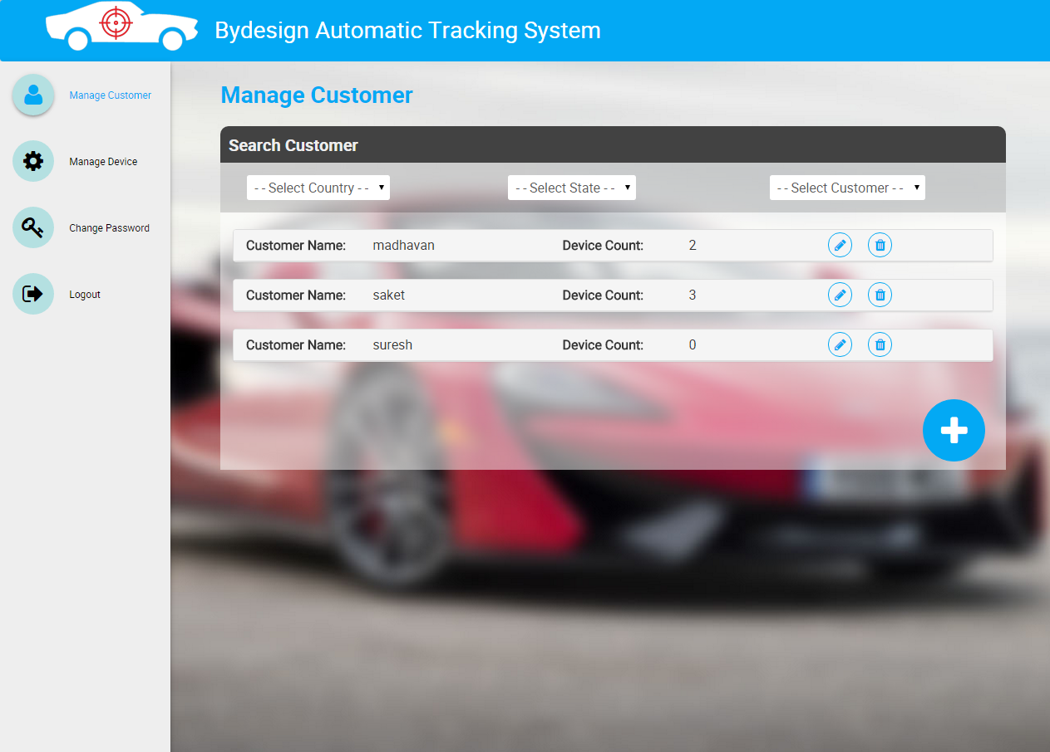

* After logging in as factory user, in landing screen there is a list of all registered customers(Admin Users) with customer name & Device Count(Devices assigned by factory user to admin user).
* User can filter the customer based on country, state & customer name

**1.1 Create New Customer**

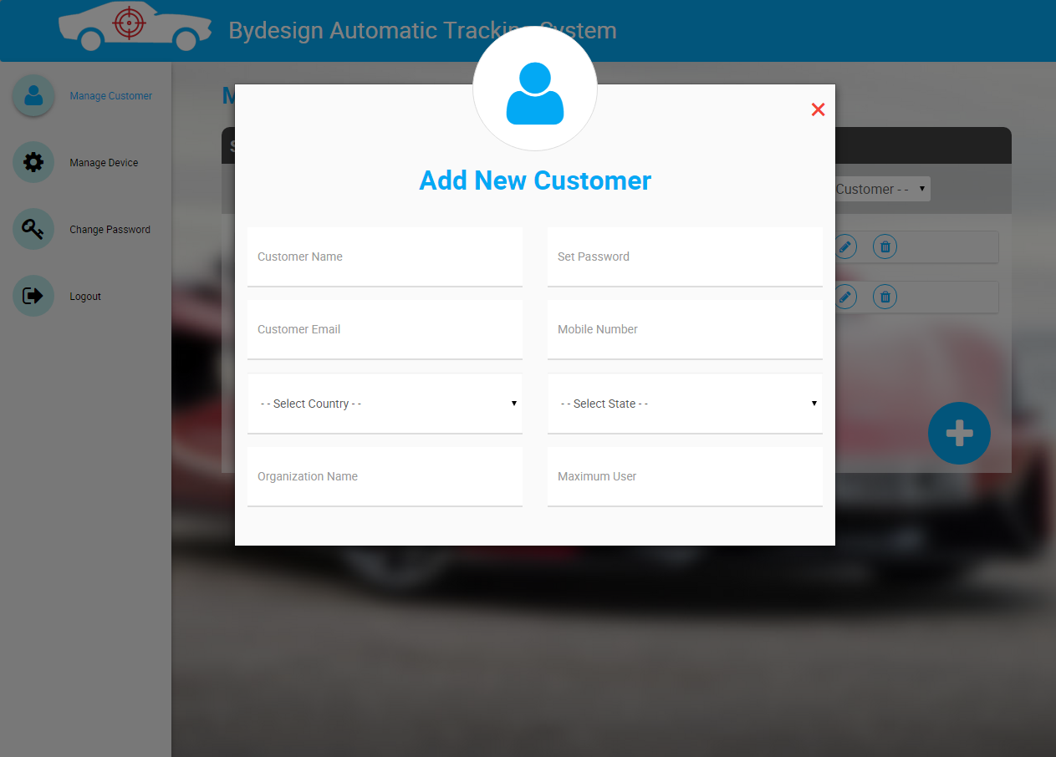

* Onclick of “Plus icon”, you can see a add new customer form, where you can fill details and create a new customer(Admin User).
* The fields in the form are,
  + Customer Name
  + Password
  + Email
  + Mobile Number
  + Country
  + State
  + Organization Name
  + Maximum Users (Maximum number of general users, admin can create)
* Onclick of “cross icon” on top right corner of form, the form will get closed.

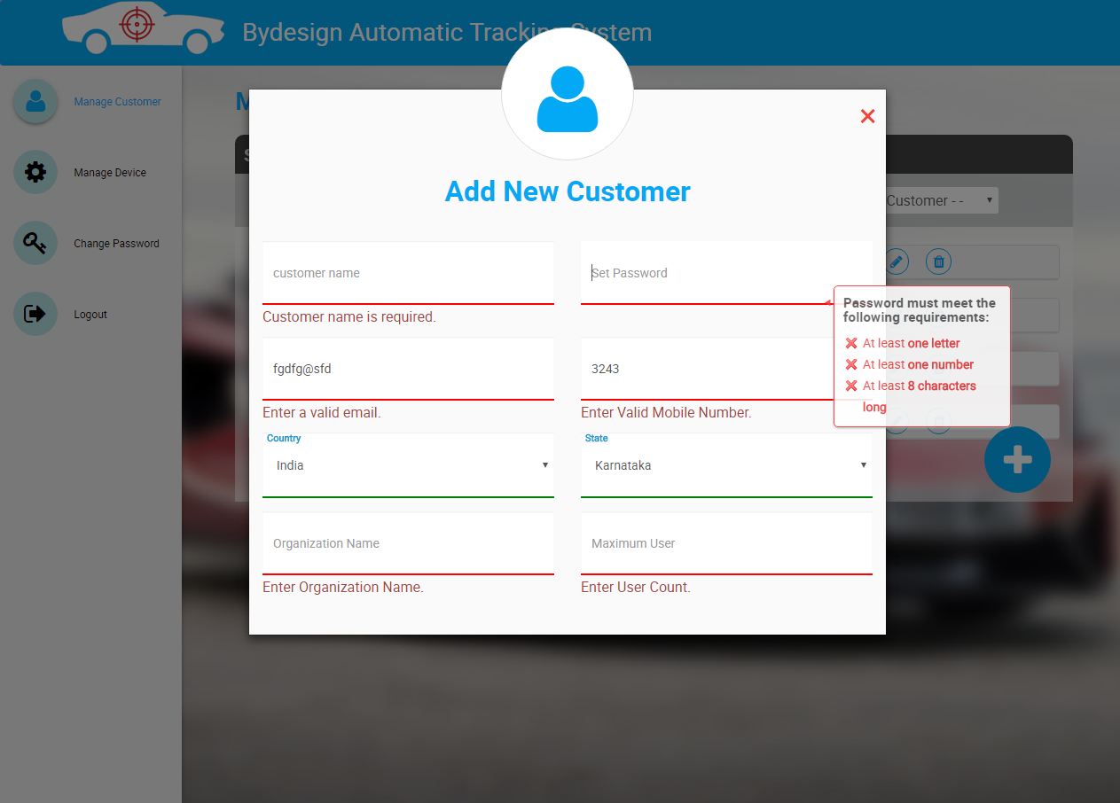

* The form is validated and all the validation messages are shown above.
* If user is trying to create customer without entering any of the mandatory fields, it will show error messages.

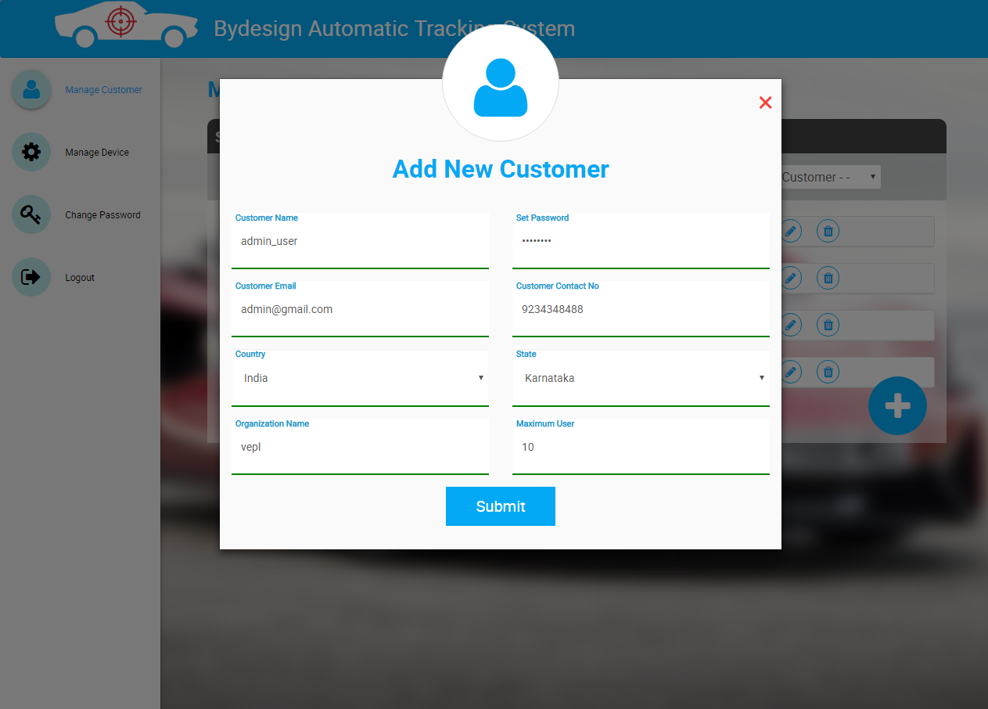

* Once all the fields are filled properly, then the submit button will be visible.

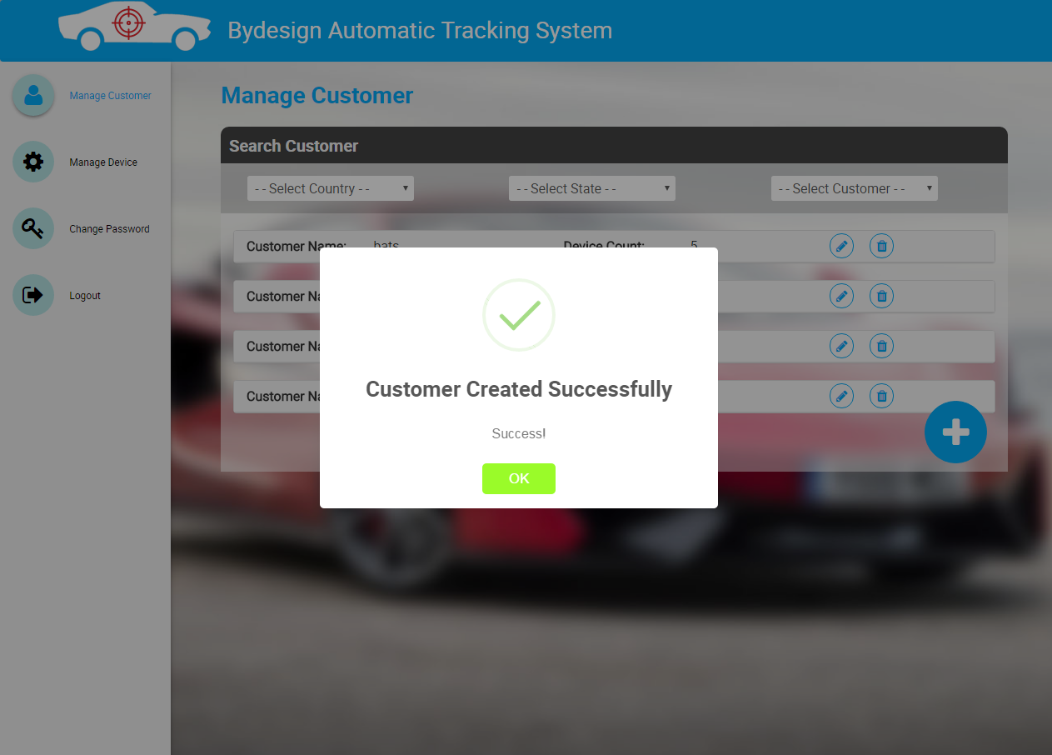

* On click of submit button, an alert is shown as “Customer Created Successfully”.

**1.2 Update Customer**

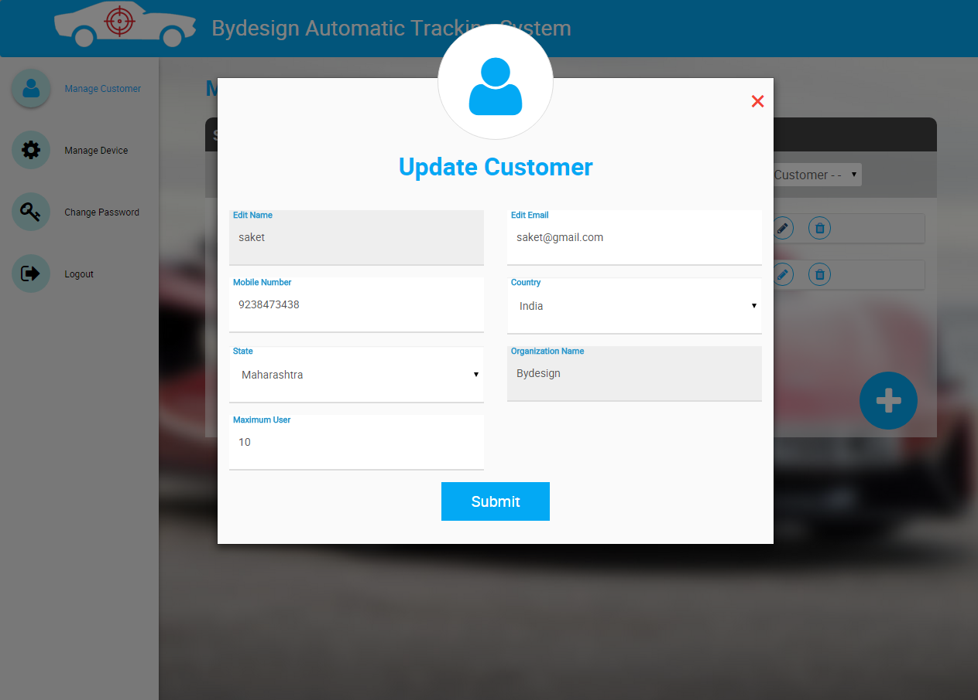

* Onclick of “Pencil icon” on the list, you can see a form with details filled of particular customer.
* User can edit the details and update the form.
* The fields in the form are,
  + Customer Name
  + Email
  + Mobile Number
  + Country
  + State
  + Organization Name
  + Maximum Users (Maximum number of general users, admin can create)

**NOTE:** Customer & Organization Names are not editable.

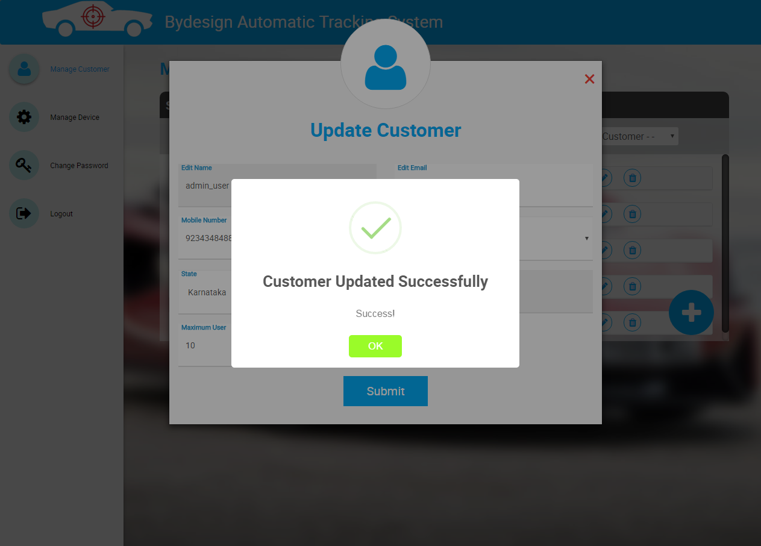

* On click of submit button, an alert is shown as “Customer Updated Successfully”.

**1.3 Delete Customer**

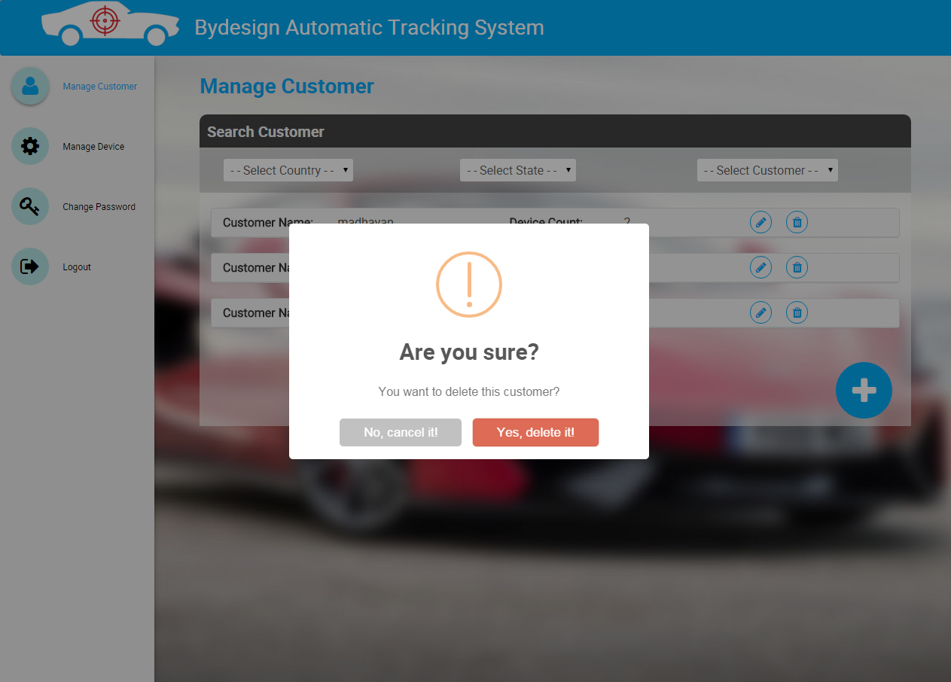

* By clicking on “Trash icon” on the list, you can see a confirm alert for deleting the customer.

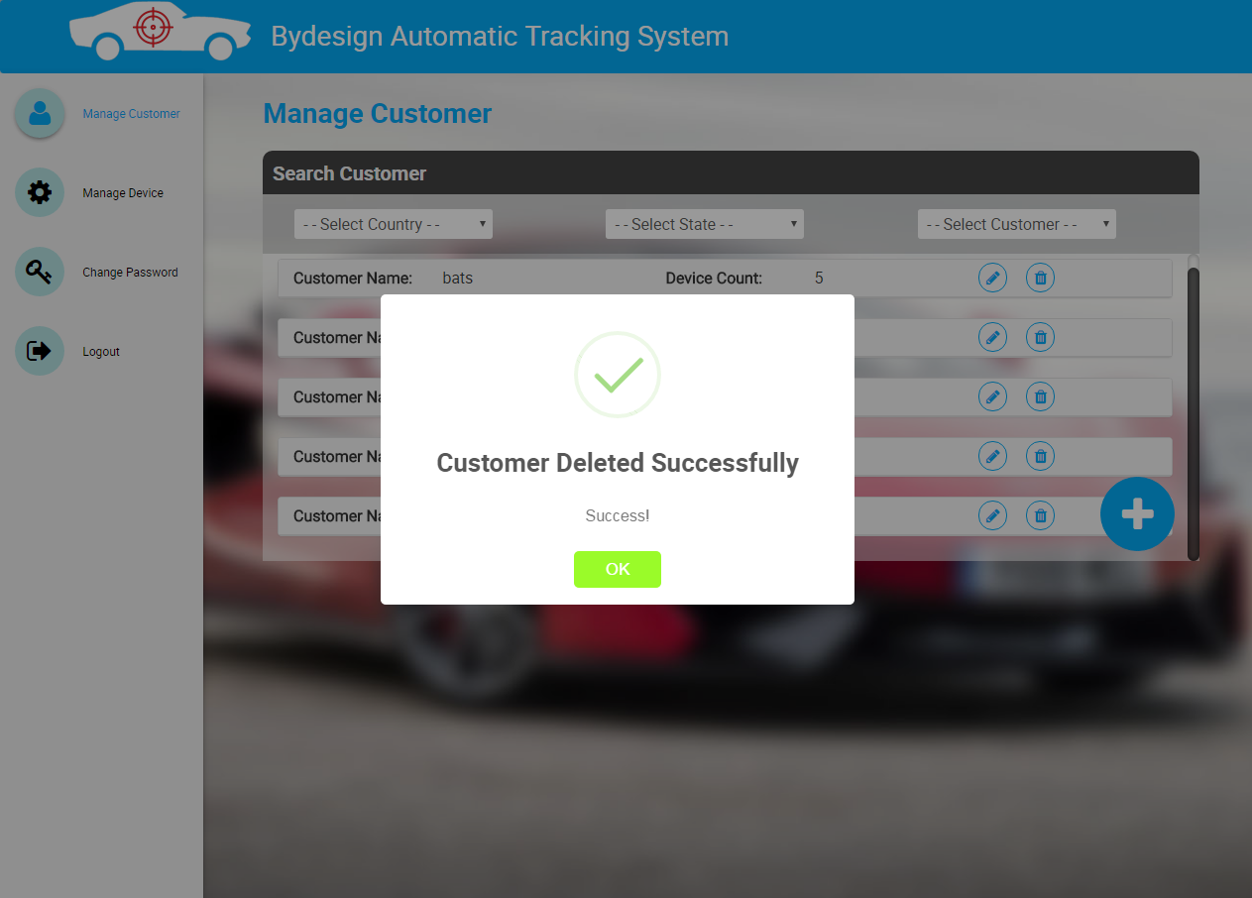

* On click of “Yes, Delete it”, an alert is shown as “Customer Deleted Successfully”.

**2. Manage Device**

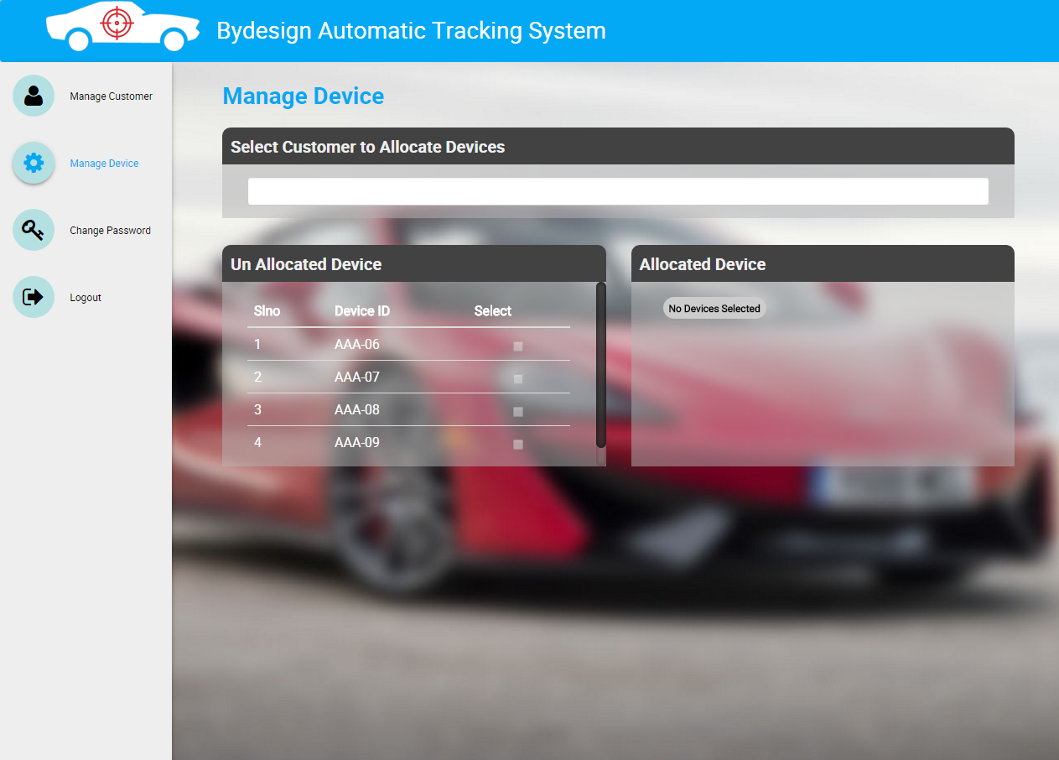

* Onclick of Manage Device menu, you can view the customer list in select customer dropdown
* All the devices from the stock will be listed in un-allocated device.

**2.1 Allocate Device to Customer**

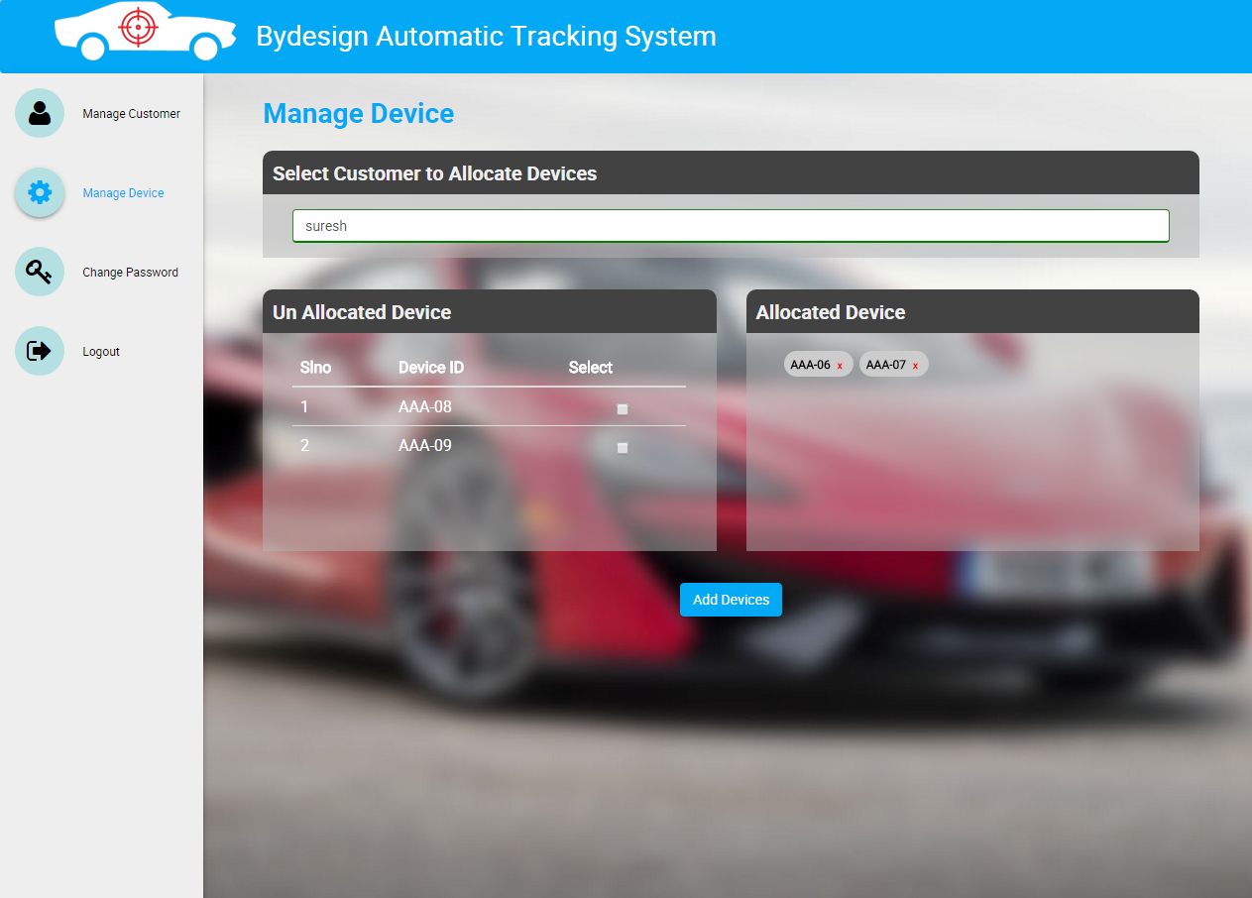

* User can select customer from select customer dropdown.
* User can select devices from unallocated device.
* All the selected devices will be listed in allocated device.
* Once customer & devices are selected then “Add Devices” button will appear.
* On click of “Add Device” button, all the allocated devices will be allocated to the particular customer.

**2.2 Allocate More Devices to Customer**

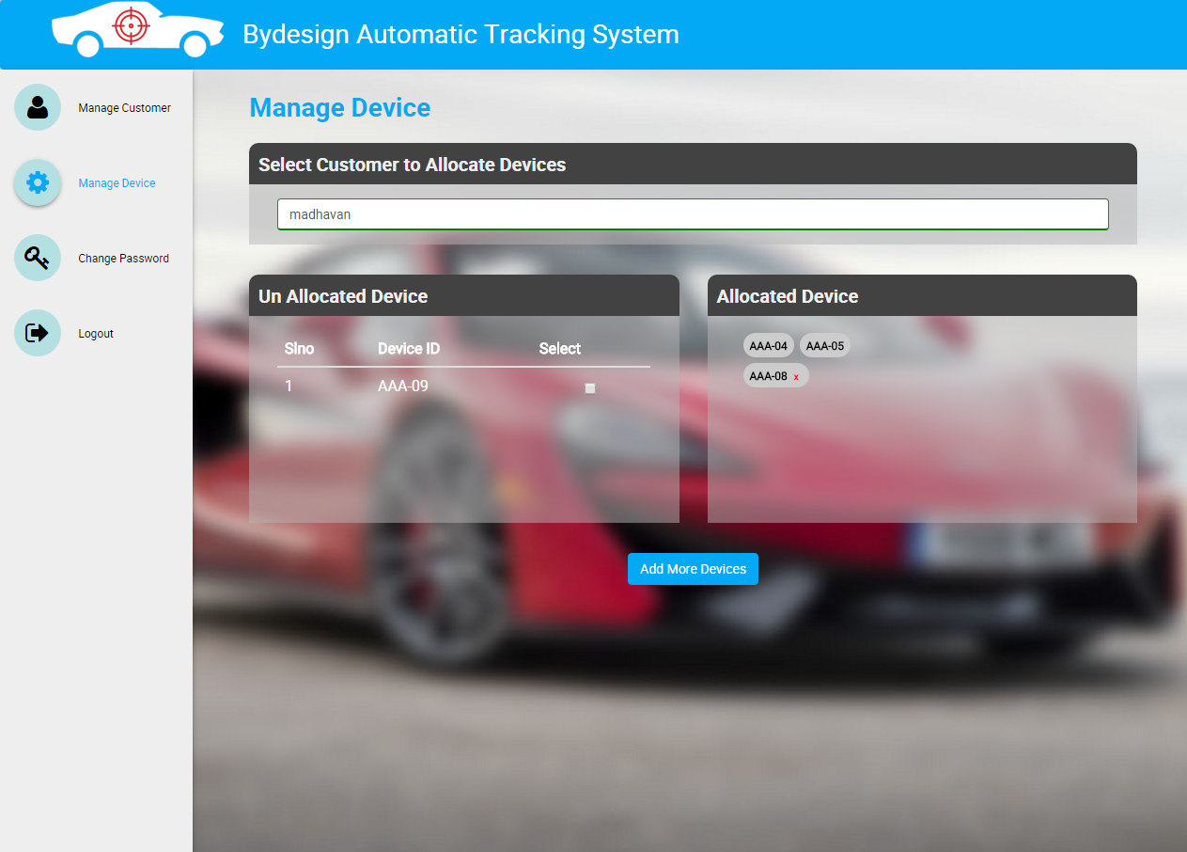

* User can select customer from select customer dropdown.
* User can view all the previously allocated devices in allocated devices.
* User can add more devices from unallocated devices.
* On click of add more devices button, all the newly allocated devices will be allocated to the particular customer.

**Admin User Overview Sketch**



**3. Manage Group**

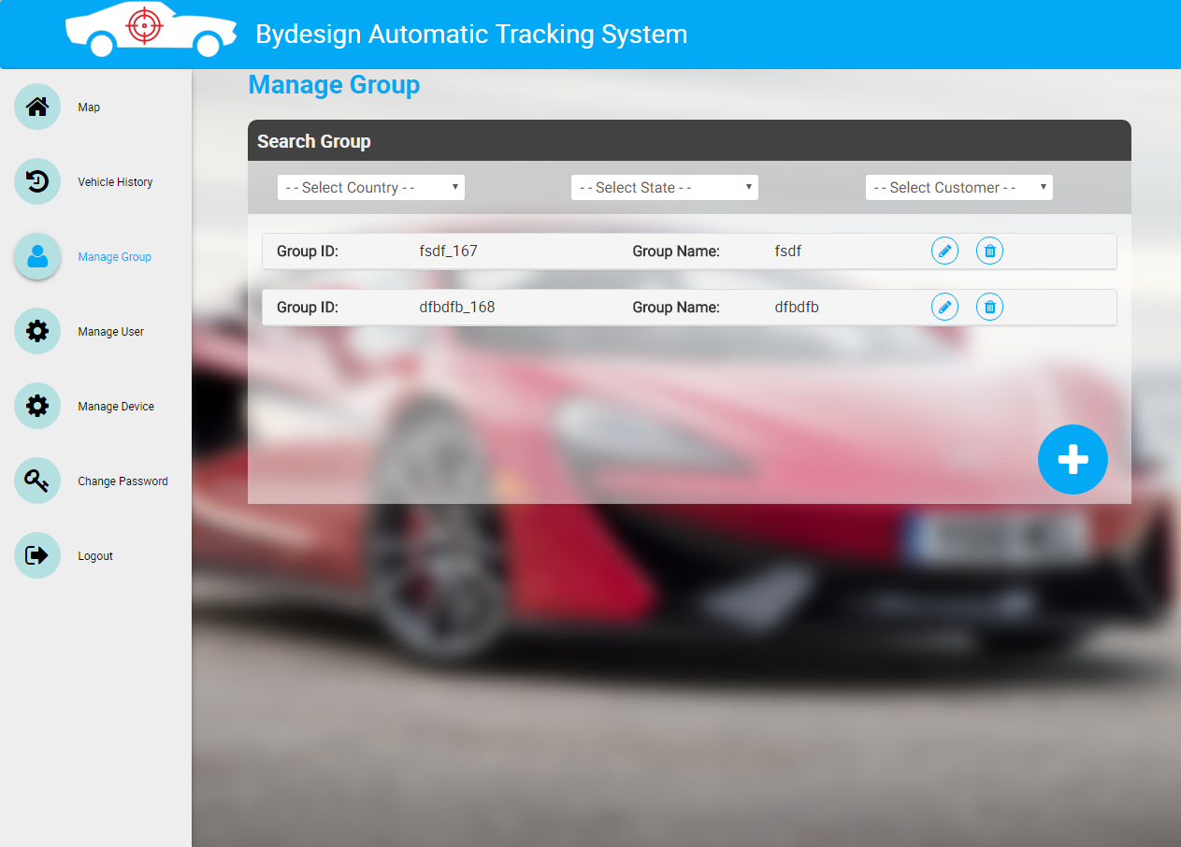

* Onclick of Manage Group menu, user can view the list of all Groups with Group Id & Group Name.
* User can filter the group based on country, state & group name.

**3.1 Create New Group**

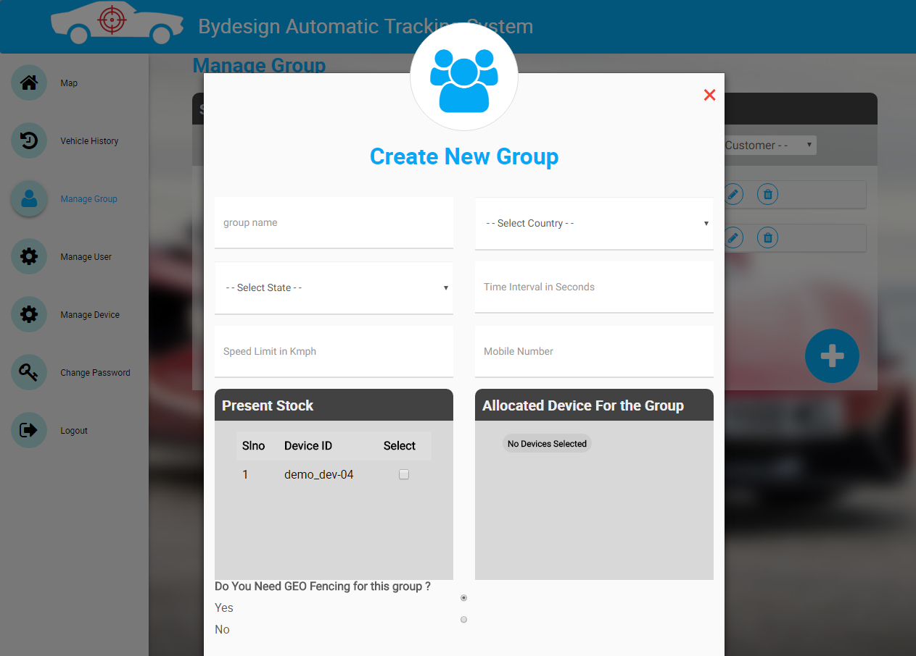

* Onclick of “Plus icon”, you can see a create new group form, where you can fill details and create a new group.
* The fields in the form are,
  + Group Name
  + Country
  + State
  + Time Interval in seconds
  + Speed Limit in kilometer per hour
  + Mobile Number
* User can allocate devices to group by selecting from present stock(Devices assigned by factory user to admin user).
* User can create group with (or) without drawing geofence, by selecting on yes/no radio buttons.

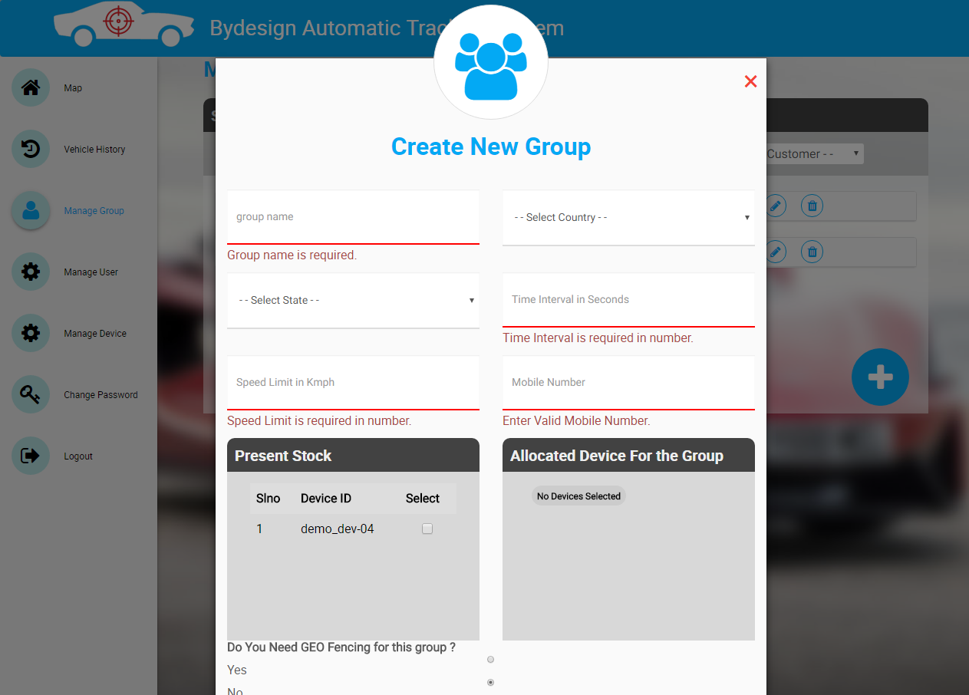

* The form is validated and all the validation messages are shown above.
* If user is trying to create group without entering any of the mandatory fields, it will show error messages.

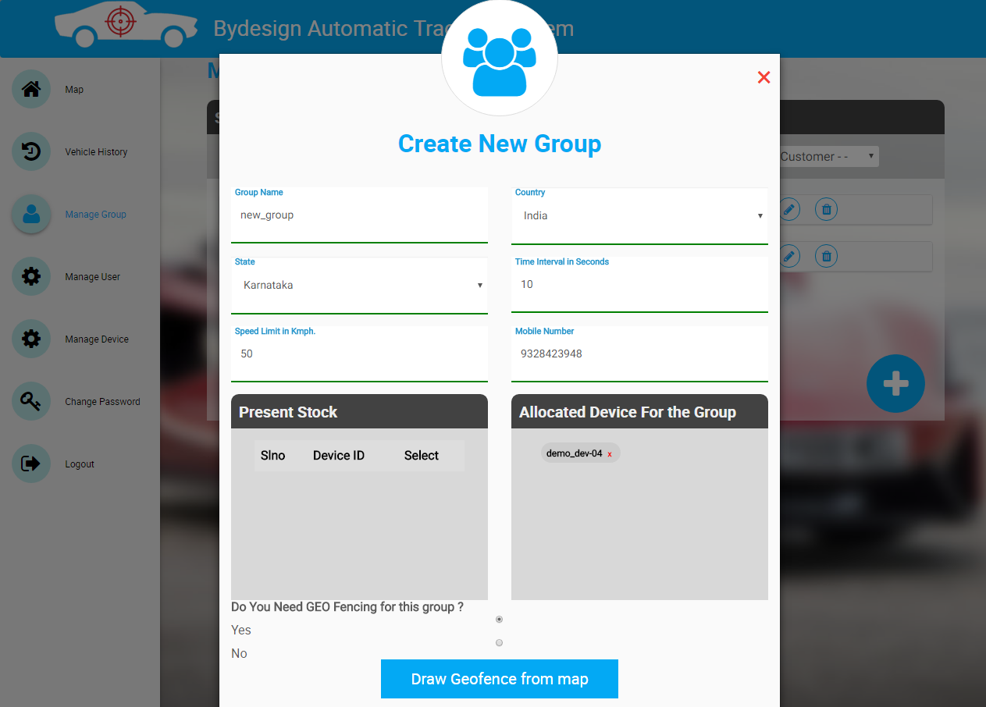

* Once all the fields are filled properly, then the submit button (or) Draw geofence from map button will be visible.
* If user clicks on submit button, the group will be created without geofence.
* If user clicks on draw geofence from map button, it will redirect to another form to draw the geofence.

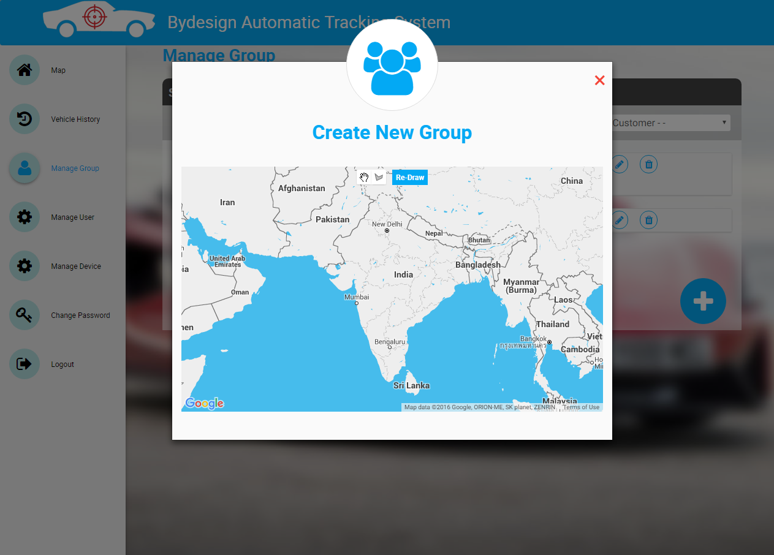

* On drawing geofence map screen, a map is shown with two icons & one button.
* First Icon(Hand icon) is used to drag the map.
* Second icon is used to draw the geofence on the map
* The Re-Draw button is used to clear the drawn geofence on the map.

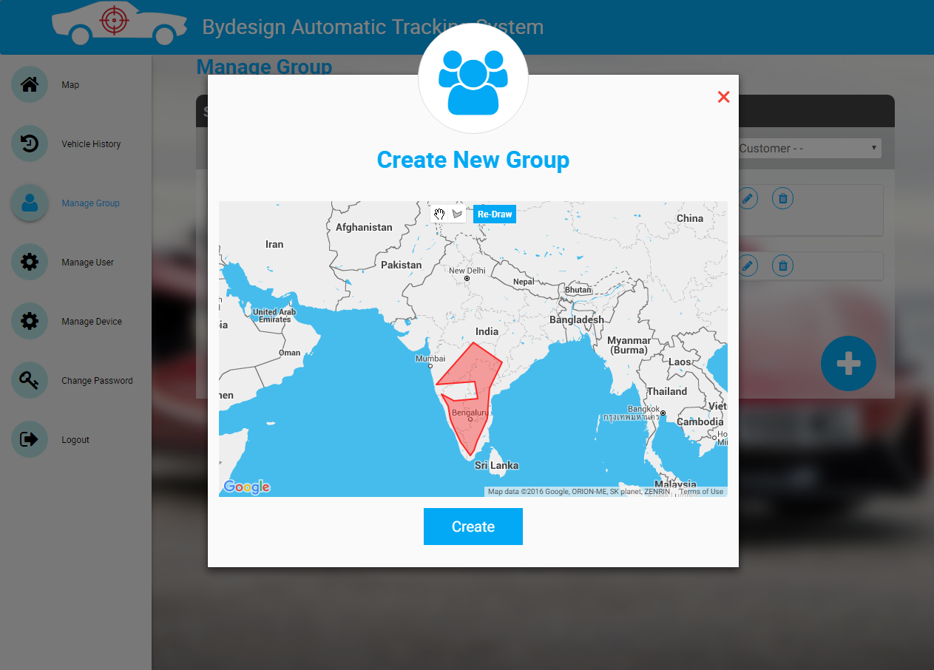

* The red color highlighted area on the map is the geofence drawn area.

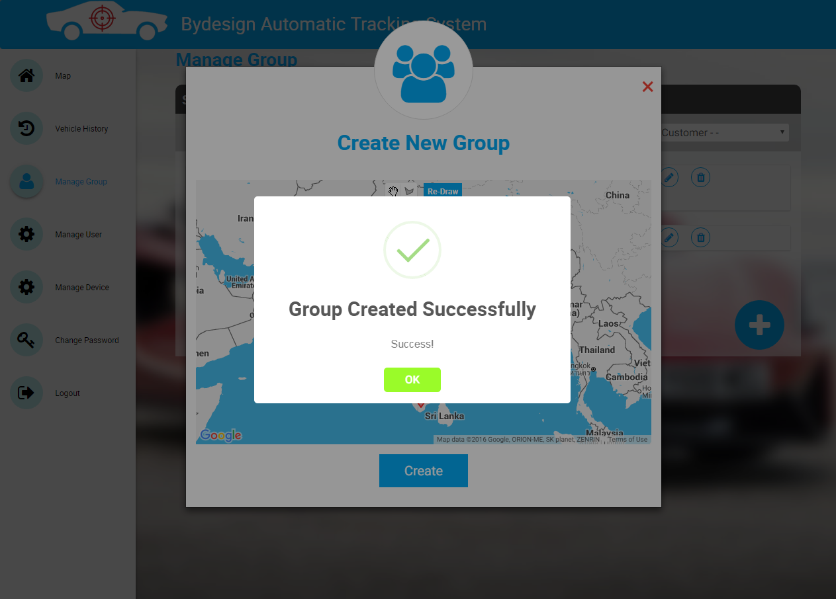

* On click of submit button, an alert is shown as “Group Created Successfully”.

**3.2 Update Group**

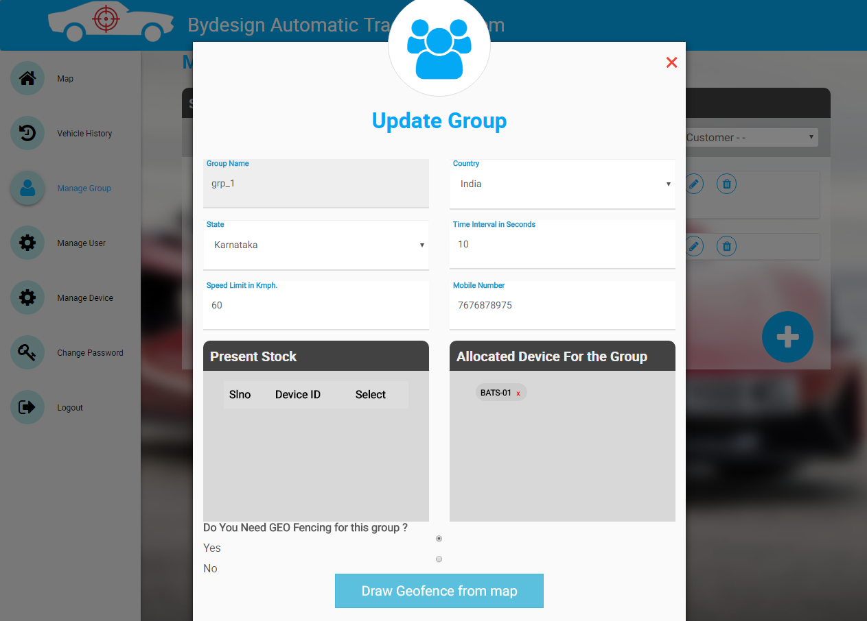

* Onclick of “Pencil icon” on the list, you can see a form with details filled of particular group.
* User can edit the details and update the form.
* The fields in the form are,
  + Group Name
  + Country
  + State
  + Time Interval in seconds
  + Speed Limit in kilometer per hour
  + Mobile Number
* User can remove already allocated devices & can allocate new devices to the group.

**NOTE:** Group Name is not editable & Once geofence is drawn, it can be editable

and can’t be removed.

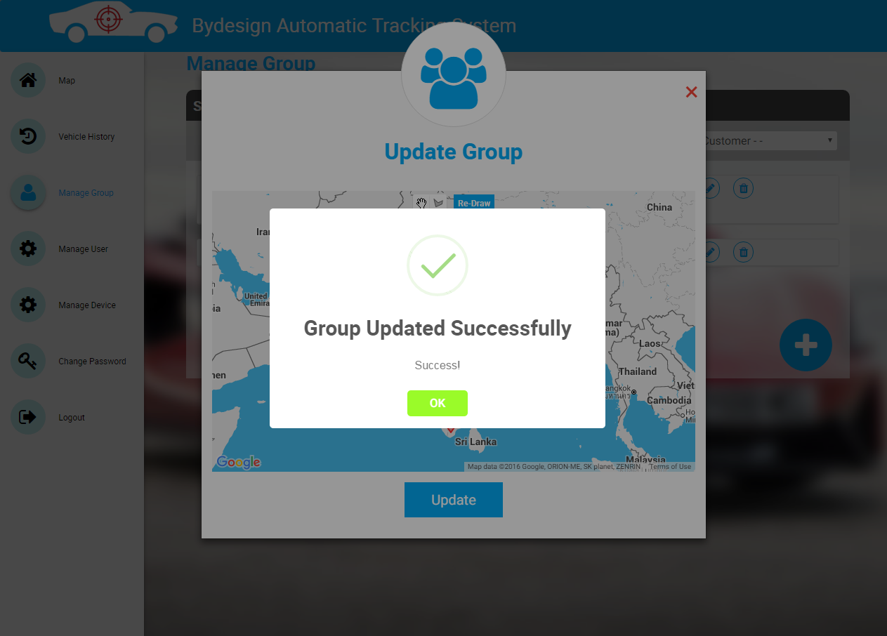

* On click of submit button, an alert is shown as “Group Updated Successfully”.

**3.3 Delete Customer**

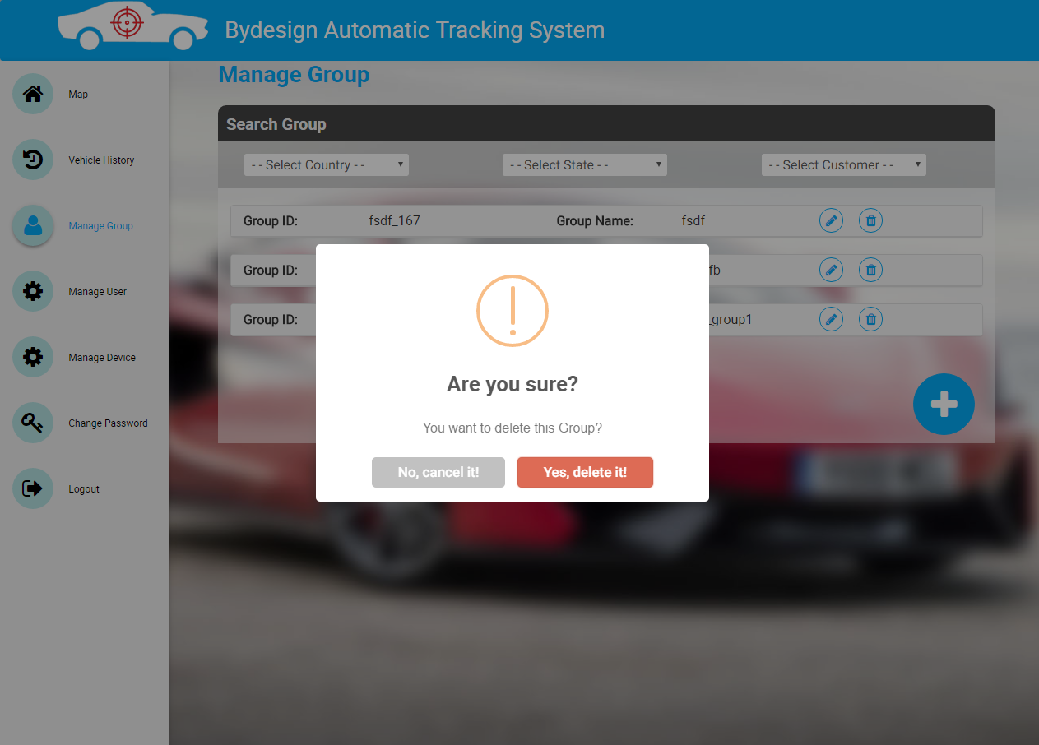

* By clicking on “Trash icon” on the list, you can see a confirm alert for deleting the group.

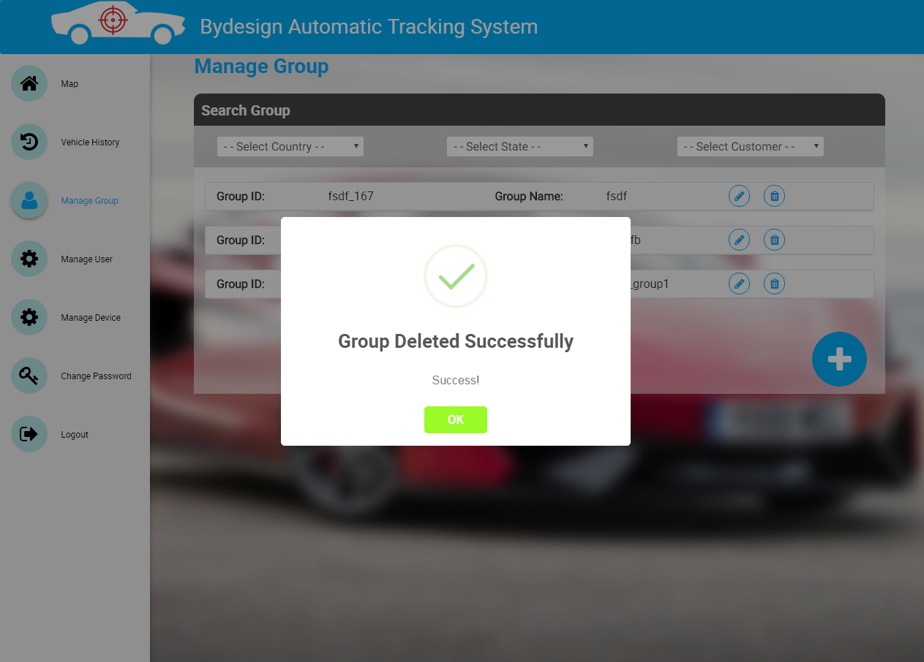

* On click of “Yes, Delete it”, an alert is shown as “Group Deleted Successfully”.

**4. Manage Device**

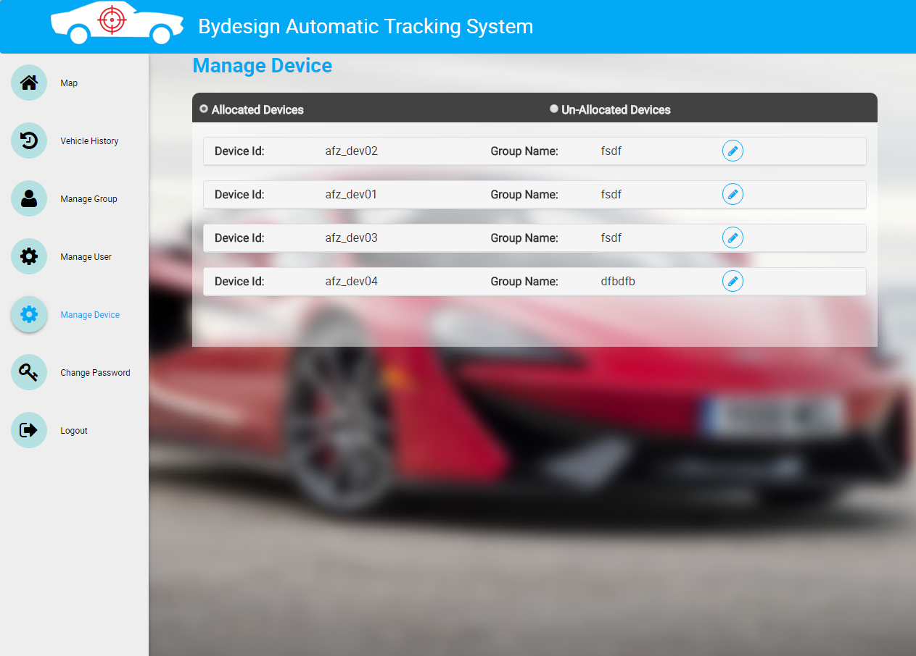

* Onclick of Manage Device menu, by default allocated devices radio button is selected, user can view the list of all allocated devices with Device Id & Group Name.

**4.1 Allocated Device Details**

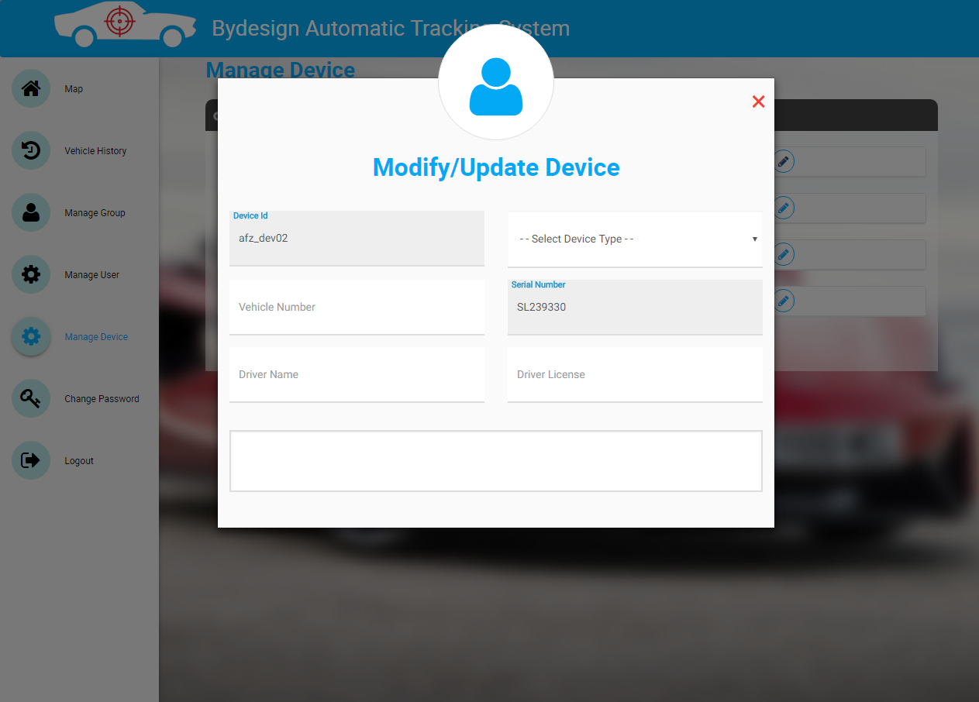

* Onclick of “Pencil icon” on the list, you can see a form with device id & serial number filled by default.
* User can modify/update the details and update the form.
* The fields in the form are,
  + Device Id
  + Device Type
  + Vehicle Number
  + Serial Number
  + Driver Name
  + Driver License
  + Description

**NOTE:** Device Id & Serial Number are not editable.

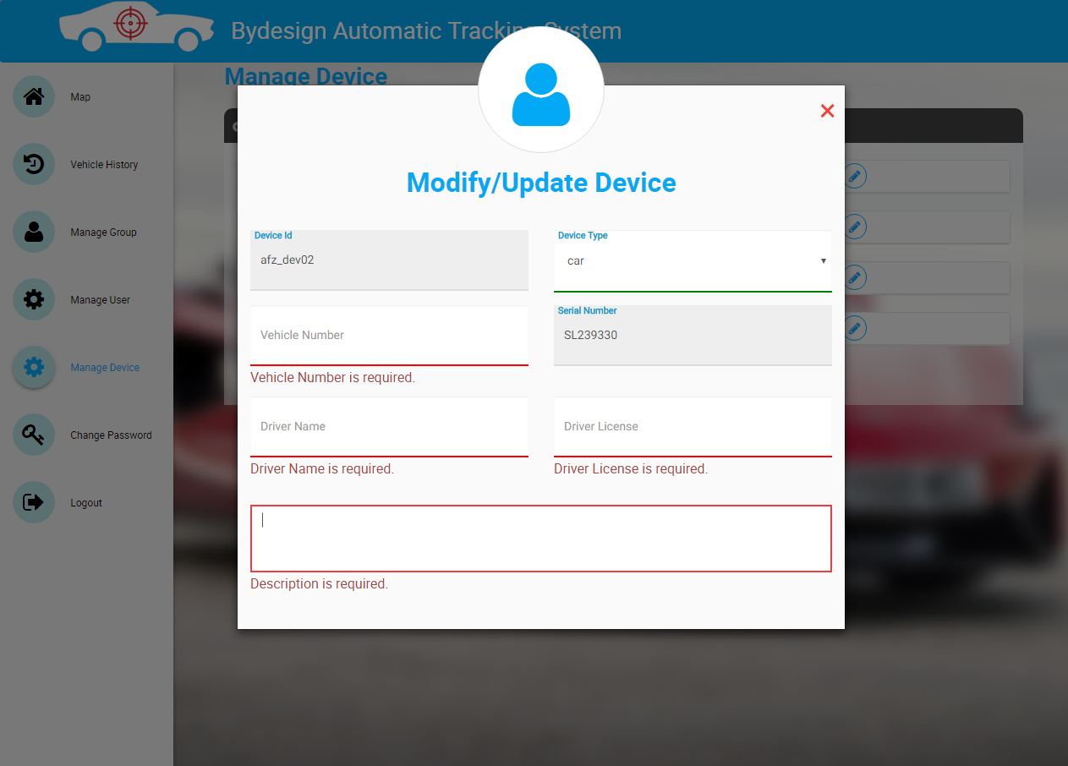

* The form is validated and all the validation messages are shown above.
* If user is trying to update device details without entering any of the mandatory fields, it will show error messages.

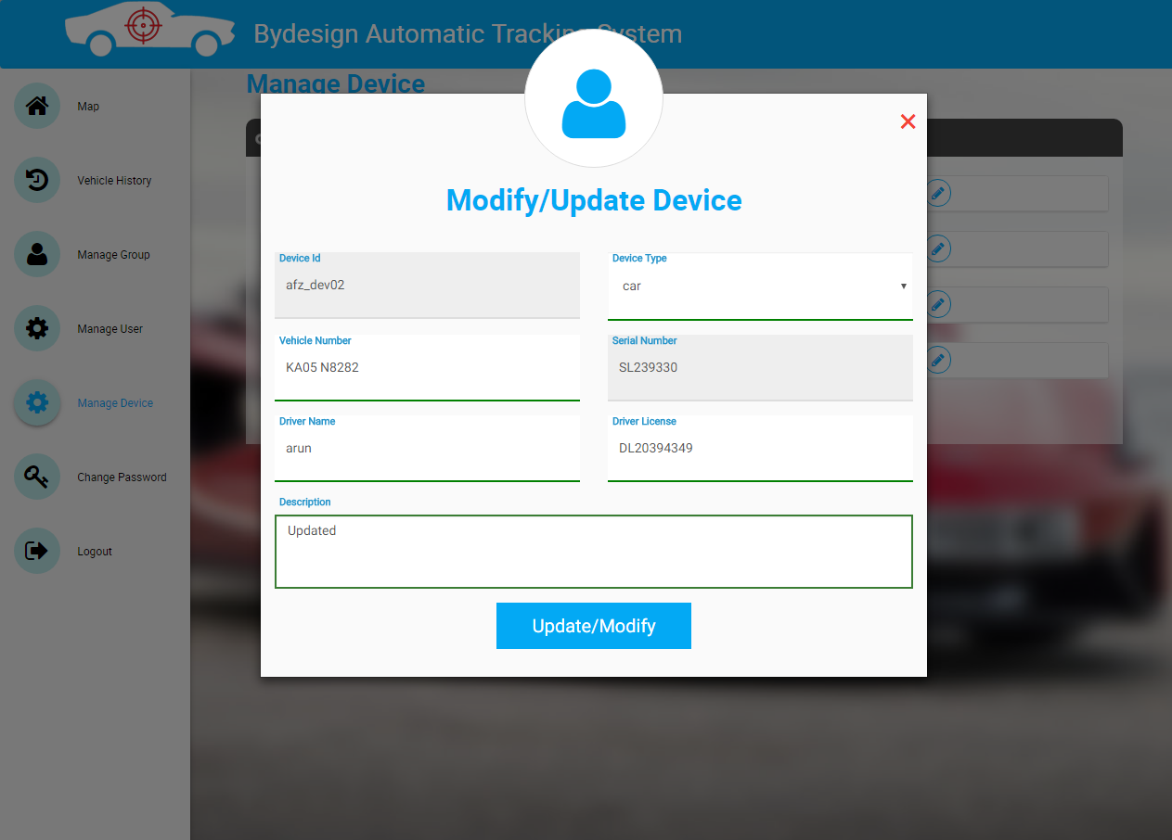

* Once all the fields are filled properly, then the Update/Modify button will be visible.

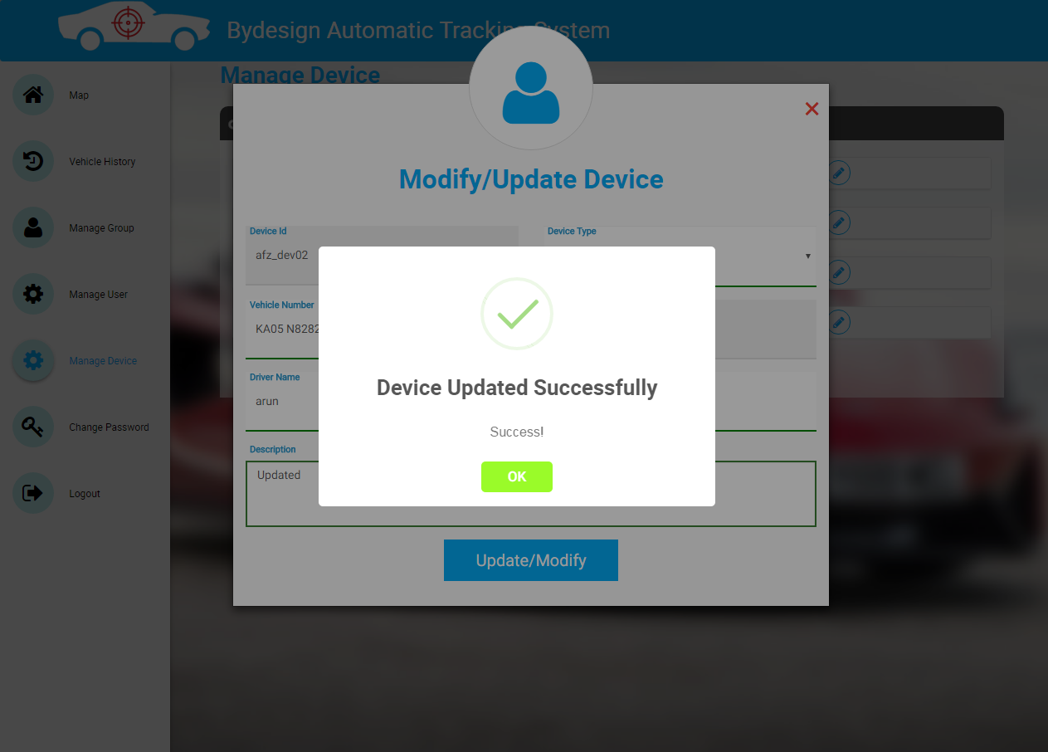

* On click of update/modify button, an alert is shown as “Device Updated Successfully”.

**4.2 Un-Allocated Device Details**

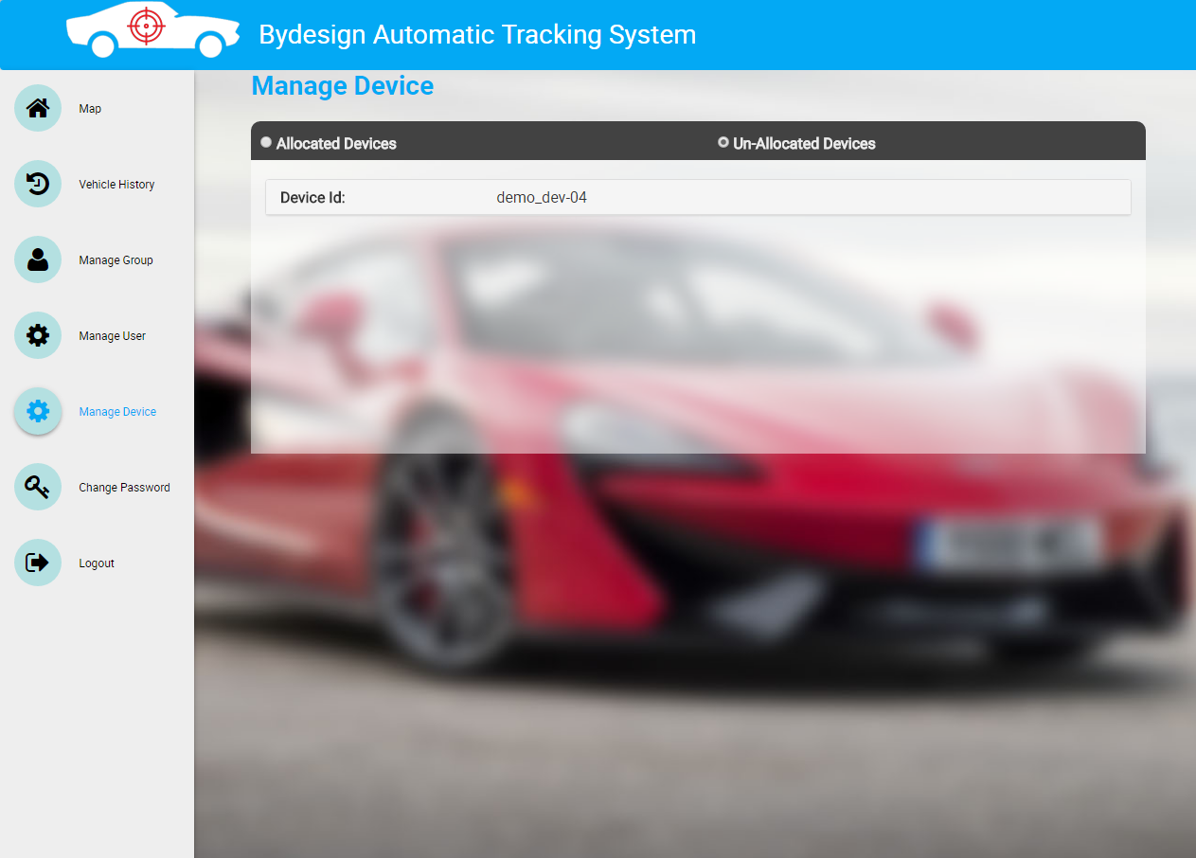

* Onclick of un-allocated devices radio button, all the devices which are not allocated to any group will be shown as list.

**5 Monitor Group/Device (Map)**

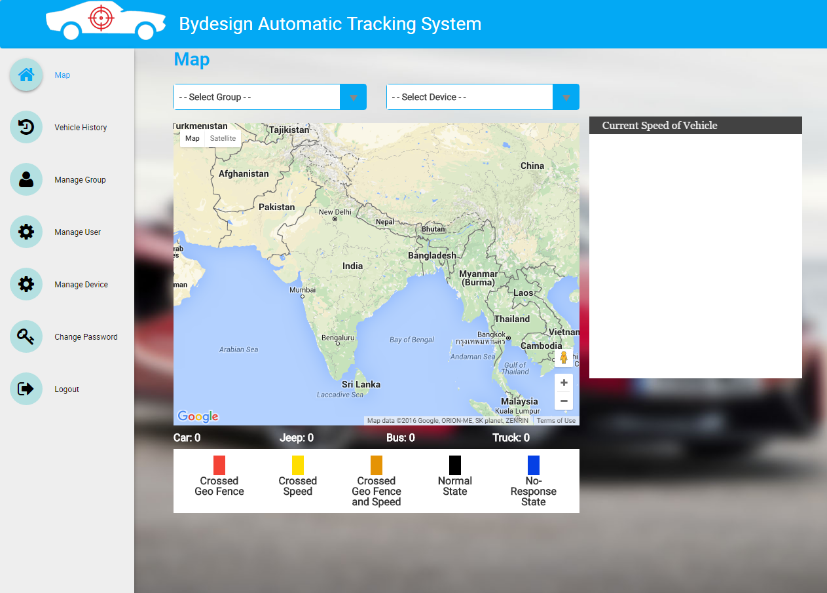

* After logging in as Admin user(Customer), the landing screen will be the above screen.
* It has selection based on,
  + Group
  + Device
* It also shows map with vehicle type & count.
* Legend with colors & description are shown below the map.
* On right of the map, an empty box is shown for tracking the current speed of the vehicle.

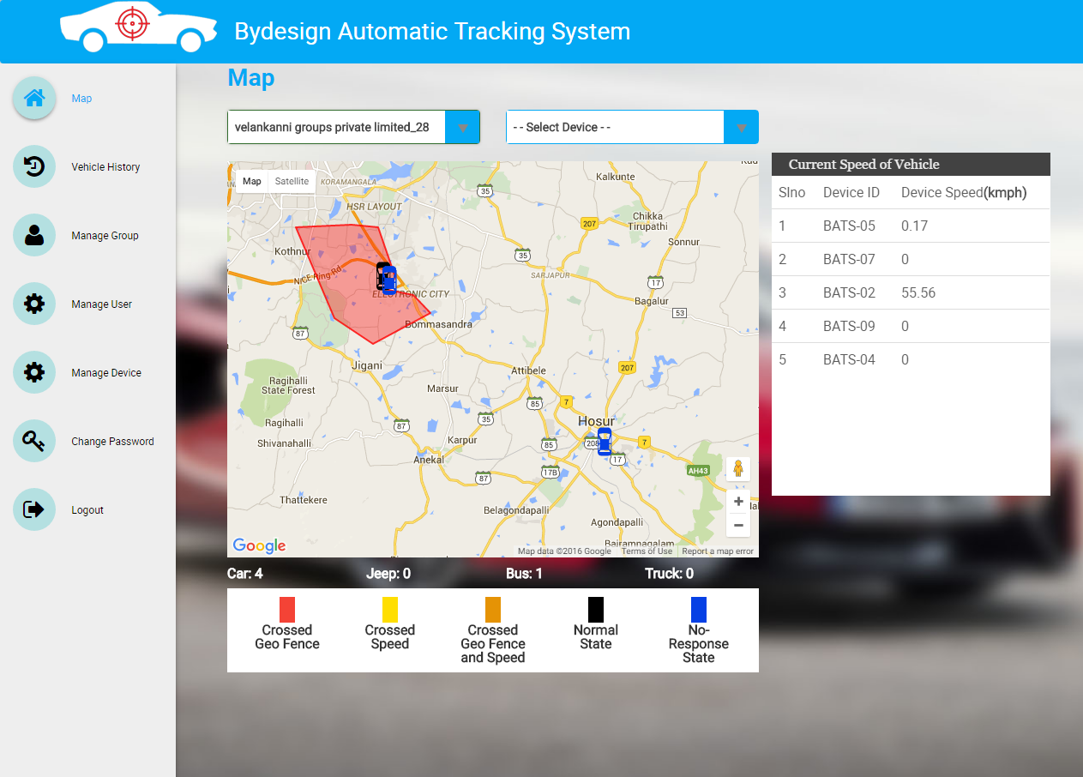

* Onselect of group from drop down, all the devices which belong to that group will be plotted on the map with geofence area drawn.
* The color of the icon on the map shows the status of the vehicle. The description for the color is shown at the bottom of the map.
* On bottom of the map, count of all the vehicles are shown.
* On right of the map, current speed of the vehicles are shown with,
  + Slno
  + Device Id
  + Device Speed

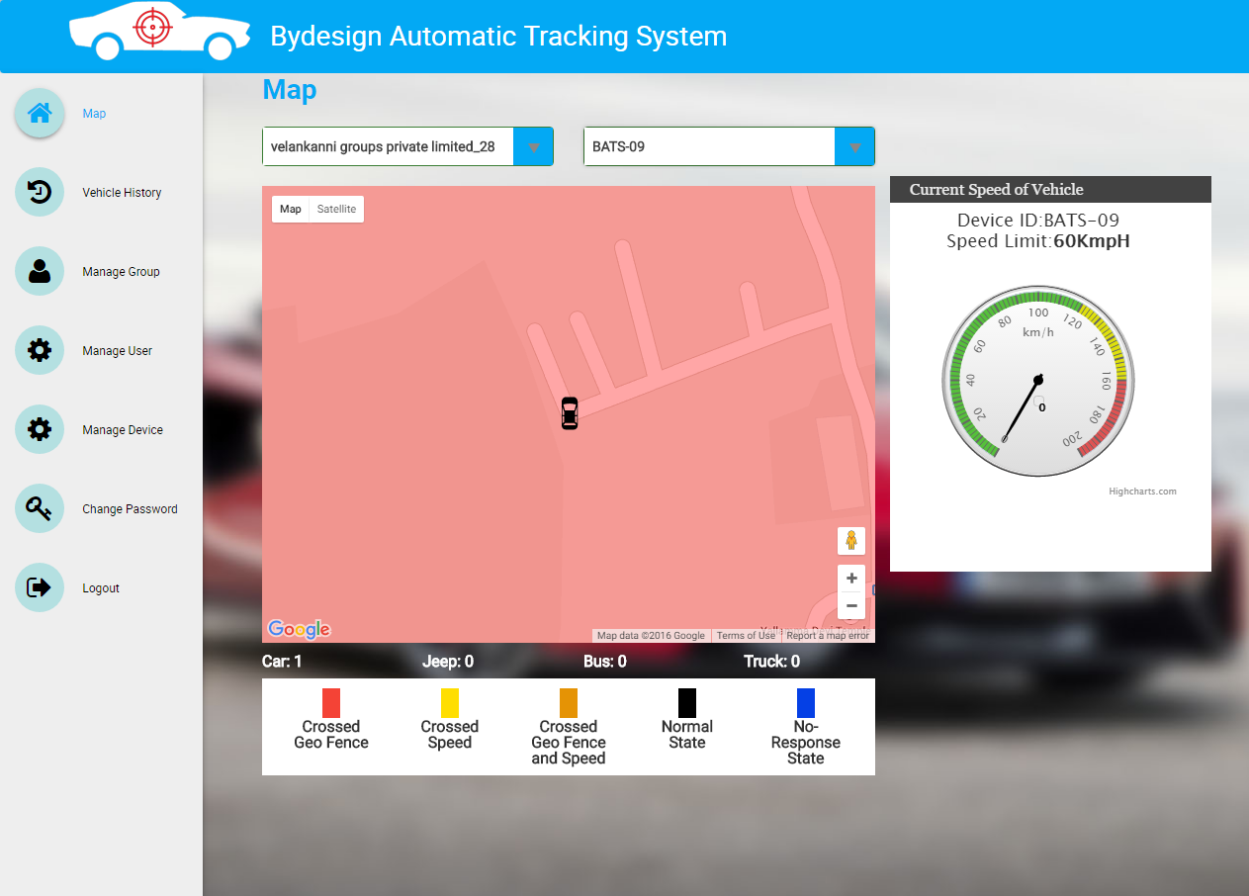

* Onselect of device from drop down, only the selected device will be plotted on the map with geofence area drawn.
* On right of the map, current speed of the vehicle is shown in speedometer.

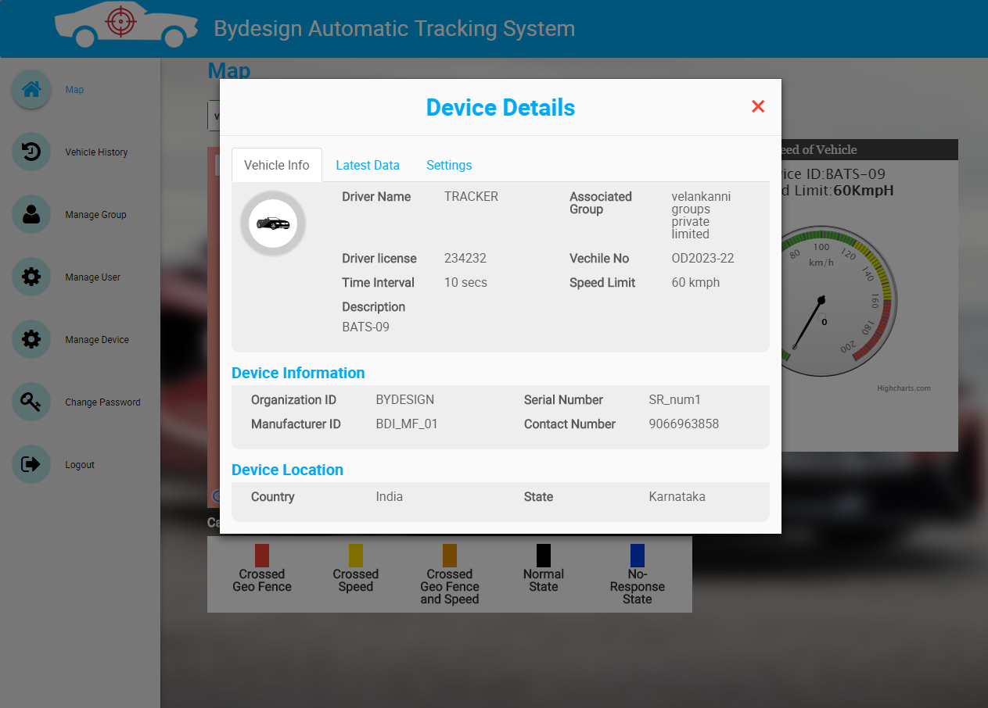

* Onclick of “Open me” button on the map, a modal is displayed with device details.
* By default, Vehicle info is selected.
* **Vehicle Info** Displays the following details,
  + Group Name
  + Driver Name
  + Driver License
  + Vehicle Number
  + Time Interval
  + Speed Limit
  + Description
  + Organization Id
  + Manufacturer Id
  + Serial Number
  + Contact Number
  + Country
  + State
* Also the car icon in the modal indicates the vehicle type.

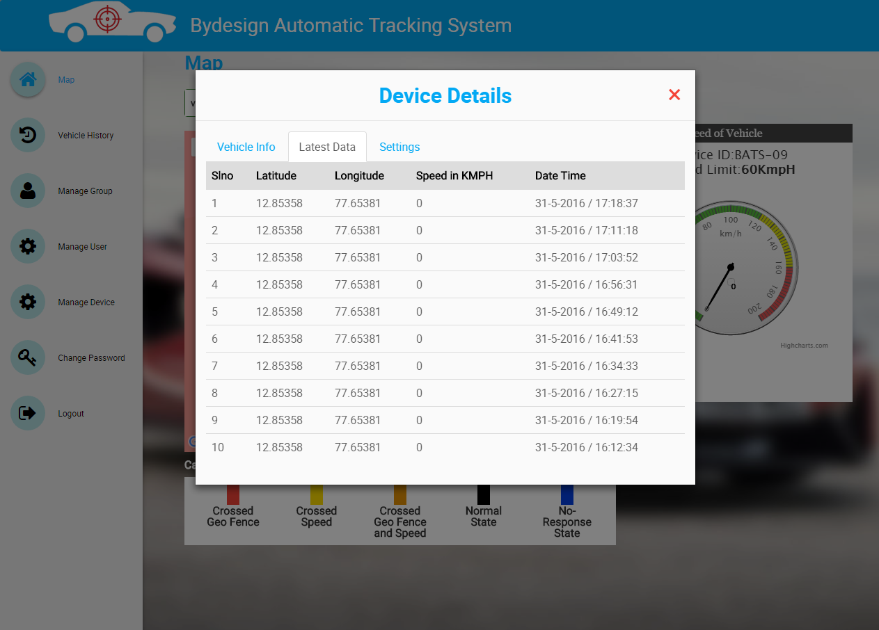

* Onclick of “Current Data” tab on the modal, it shows the last 10 data updated from the device. Such as,
  + Lat
  + Long
  + Speed
  + Date
  + Time

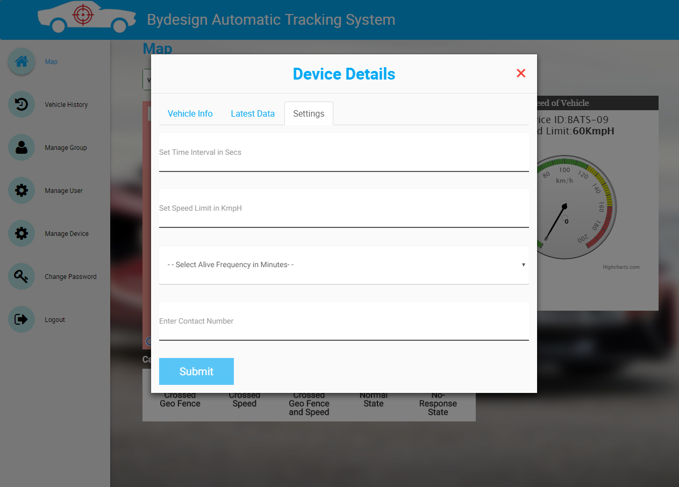

* Onclick of “Settings” tab on the modal, it shows a form with following fields,
  + Time Interval in seconds
  + Speed Limit in Kilometer per hour
  + Contact Number
* By using this form, user can set the time, speed & contact number for that device.

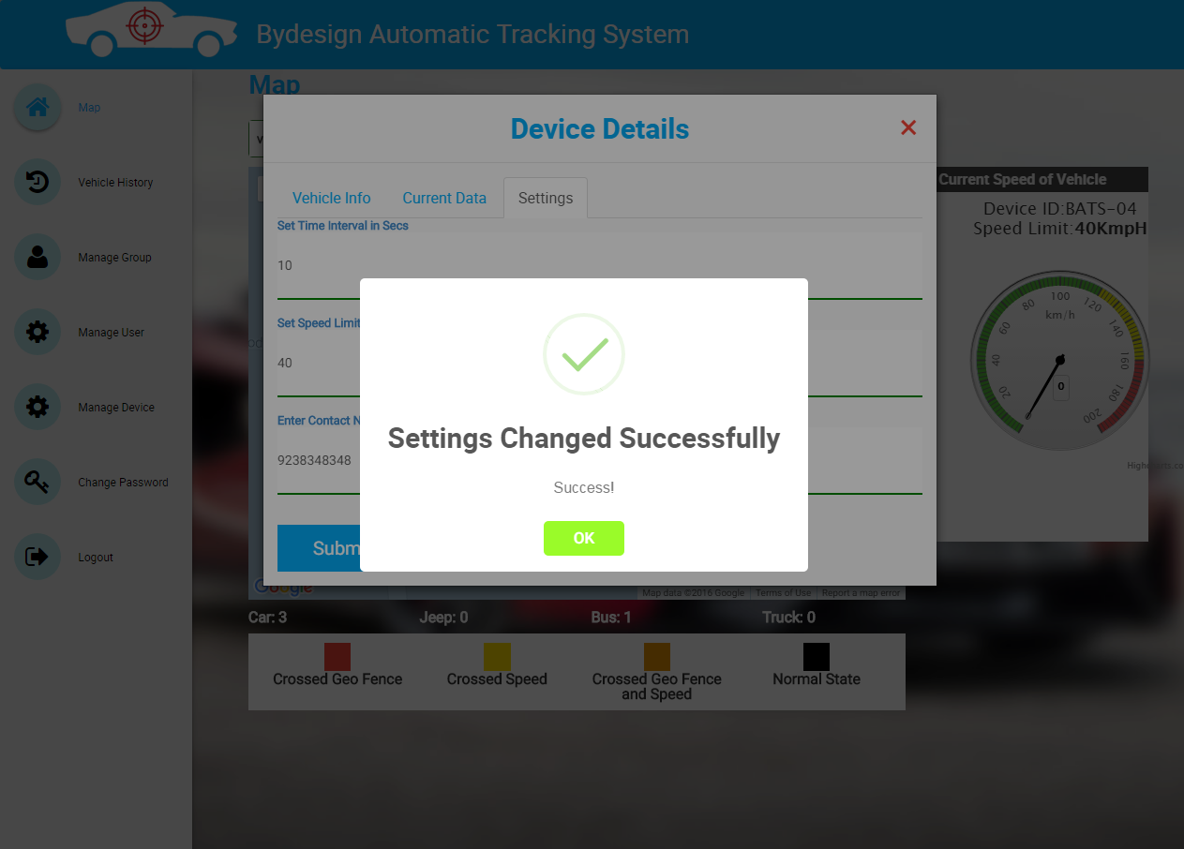

* After entering the details & submitting the form an alert is shown as “Settings Changed Successfully”.

**6. Vehicle History**

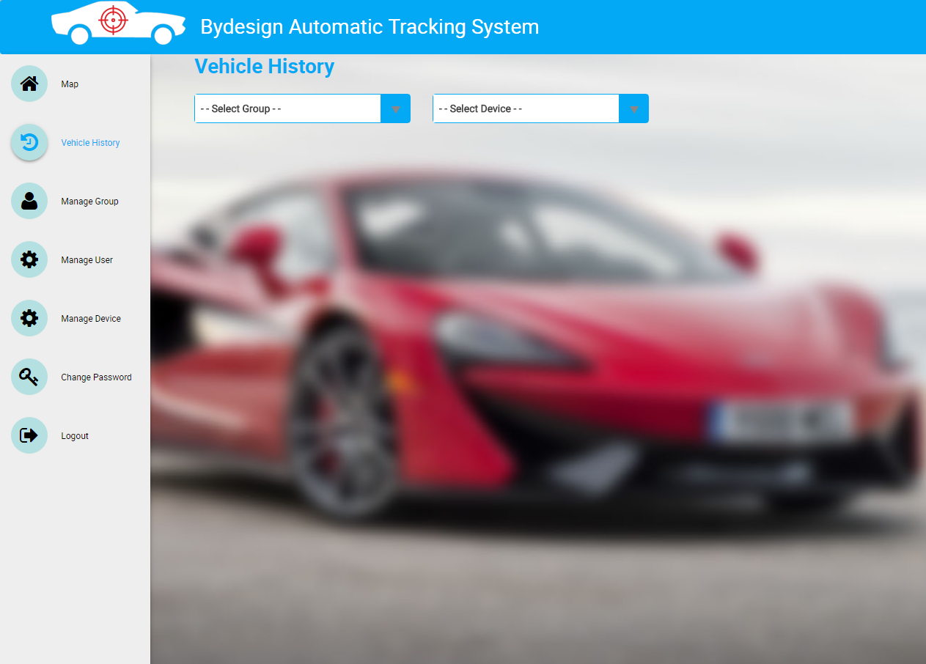

* Onclick of Vehicle History menu, two dropdown buttons are shown,
  + Group
  + Device

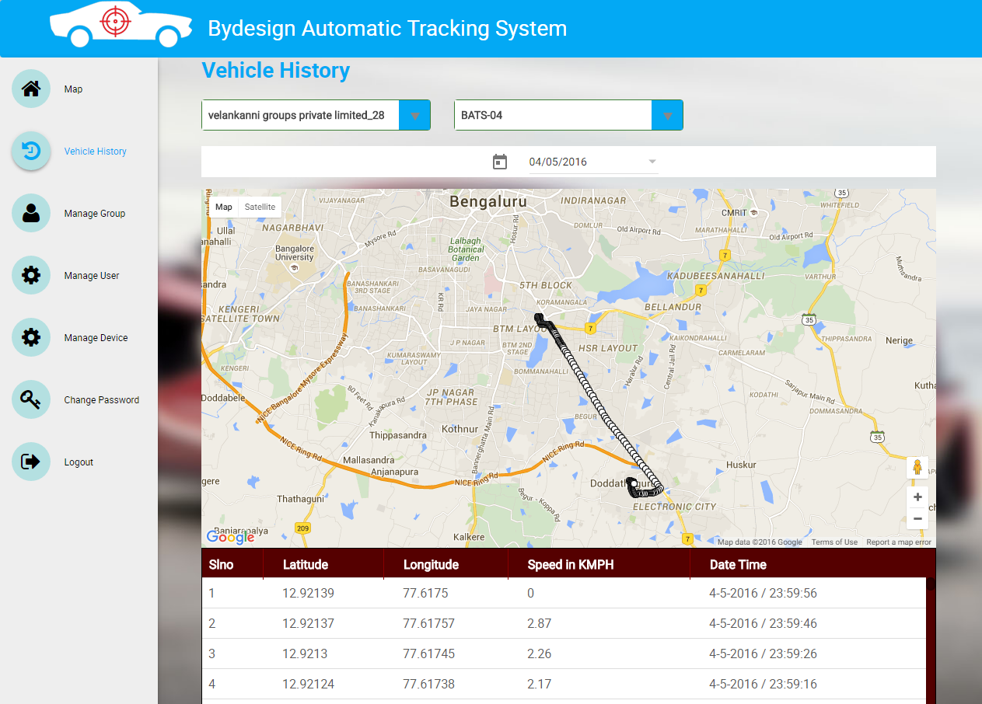

* Onselect of group, device & date, a map is shown with plotting the route where the vehicle has traveled.
* It also shows a table with following details of the device,
  + Lat
  + Long
  + Speed
  + Date
  + Time

**7. Manage User(General User)**

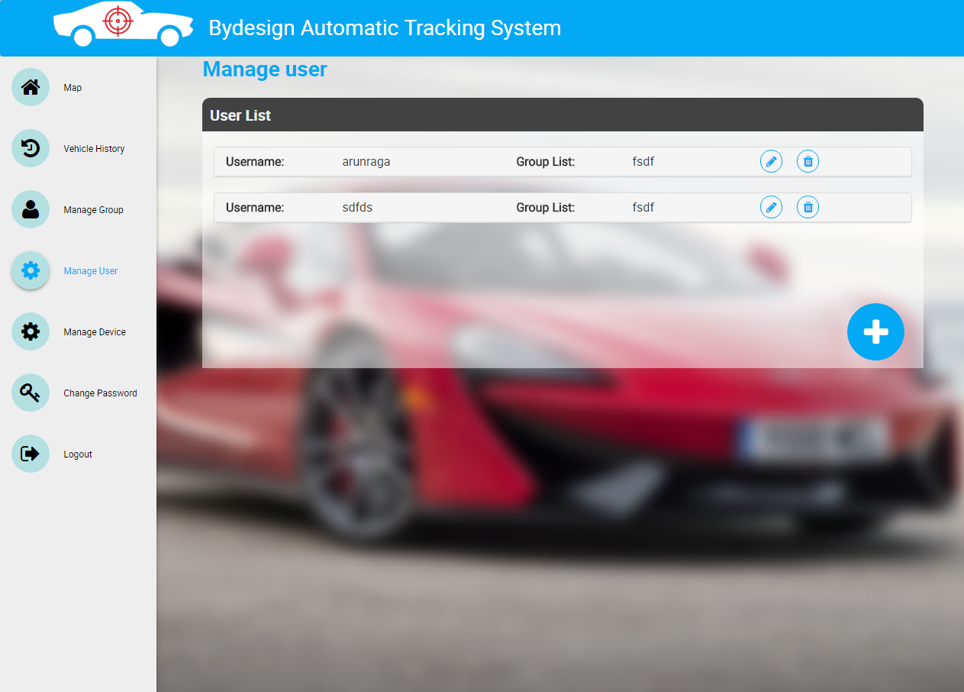

* Onclick of Manage User menu, user can view the list of all users(General Users) with User name & group list of all the assigned groups to that user.

**7.1 Create New User**

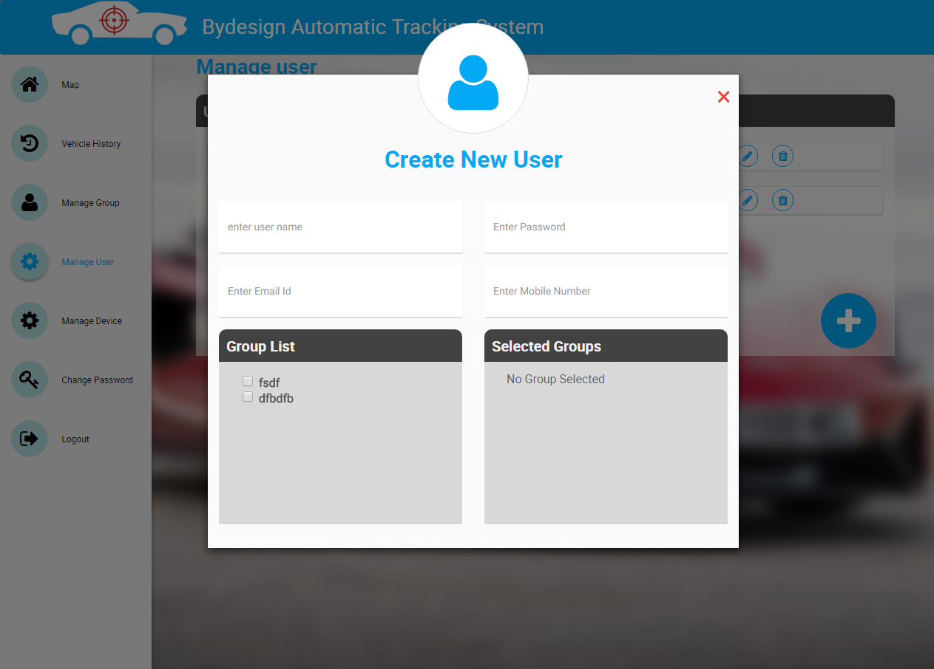

* Onclick of “Plus icon”, you can see a add new user form, where you can fill details and create a new user(General User).
* The fields in the form are,
  + User Name
  + Password
  + Email
  + Mobile Number
* List of all the groups are shown in group list.

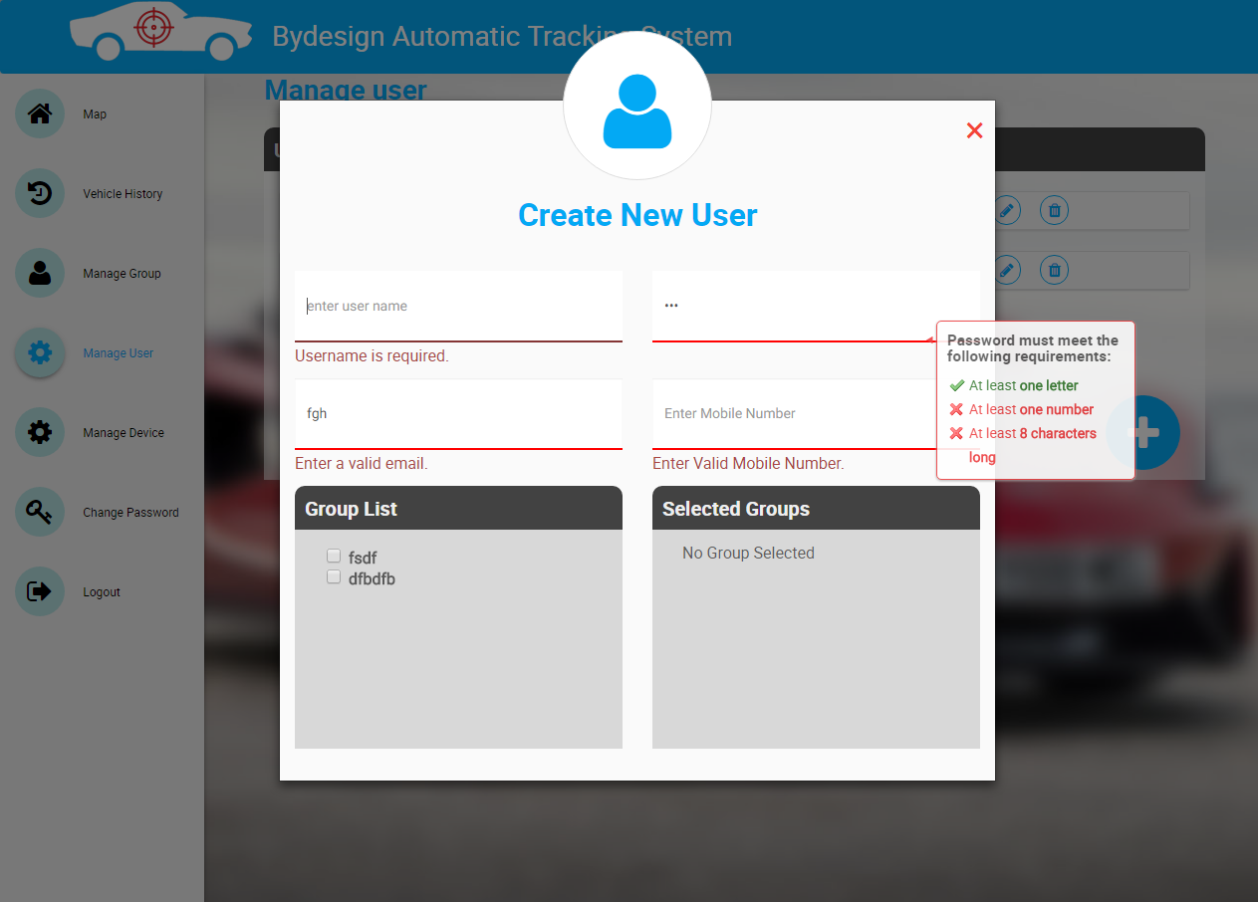

* The form is validated and all the validation messages are shown above.
* If user is trying to create general user without entering any of the mandatory fields, it will show error messages.

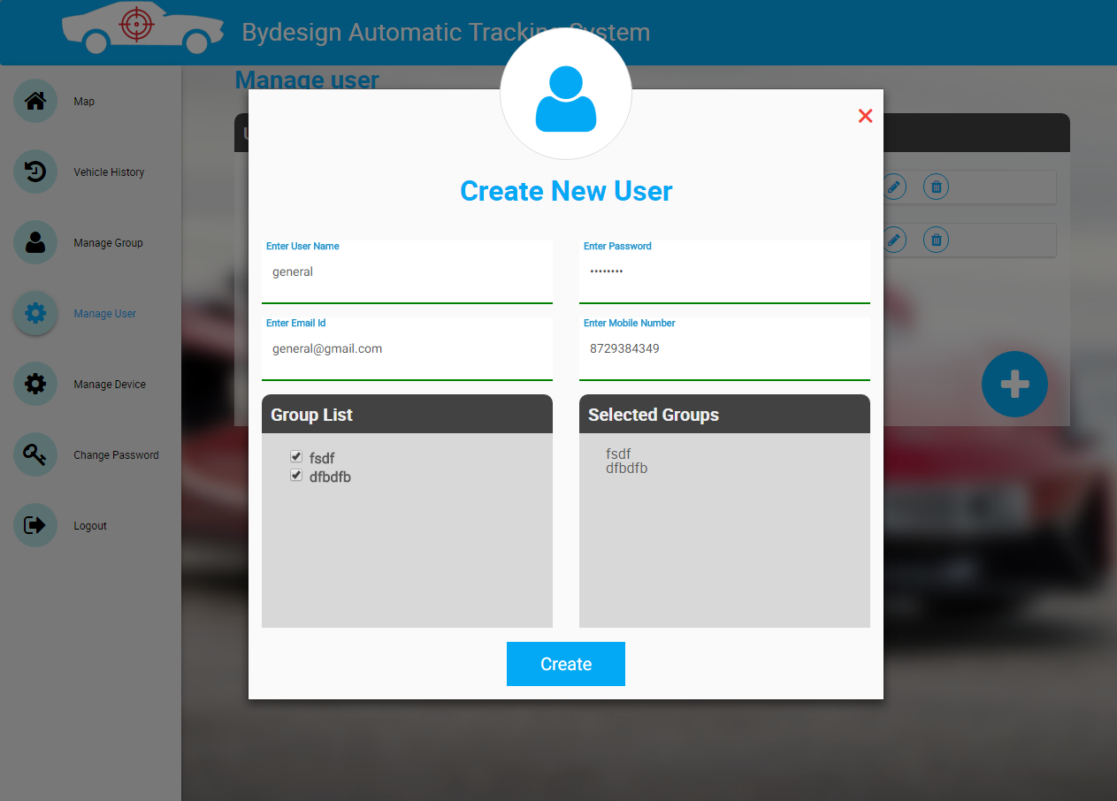

* Once all the fields are filled properly, then the submit button will be visible.

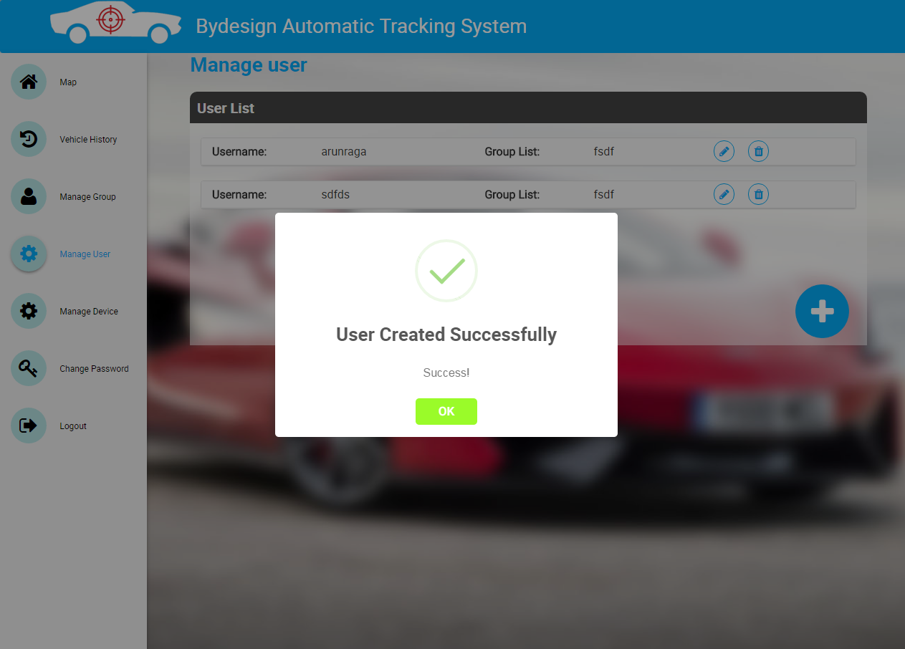

* On click of submit button, an alert is shown as “User Created Successfully”.

**7.2 Update User**

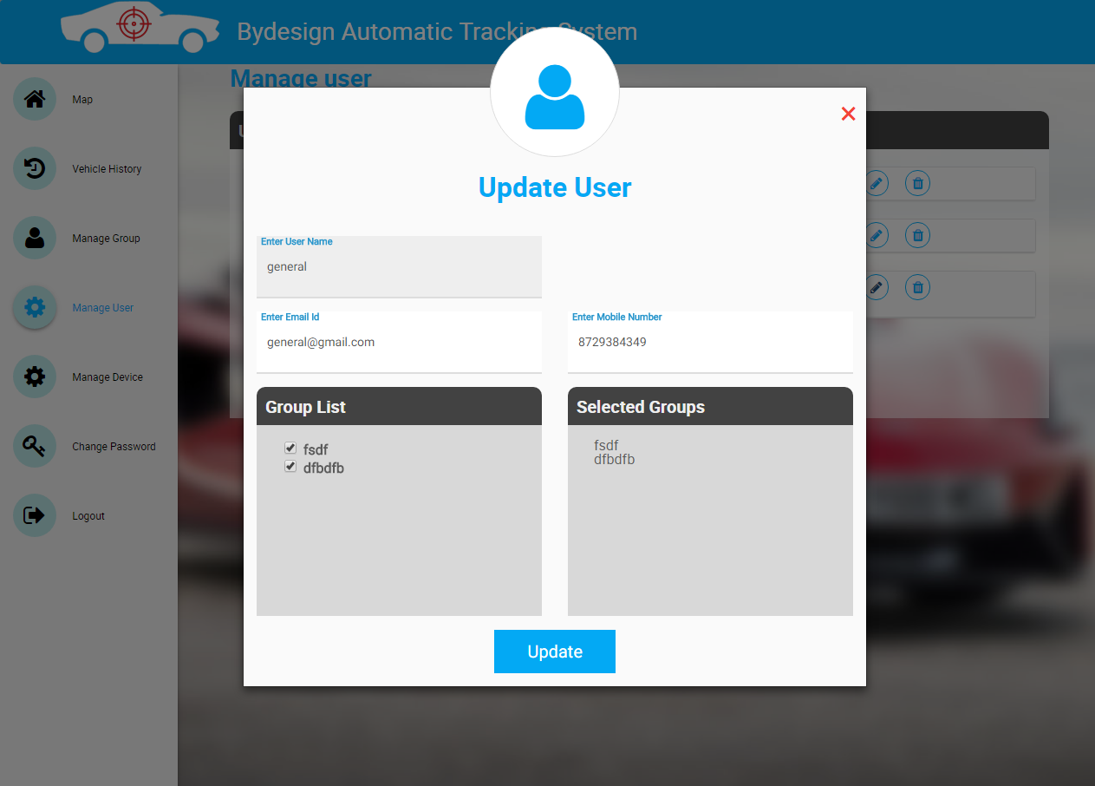

* Onclick of “Pencil icon” on the list, you can see a form with details filled of particular user.
* User can edit the details and update the form.
* The fields in the form are,
  + User Name
  + Email
  + Mobile Number
* Selected group list is also shown.

**NOTE:** Username is not editable.

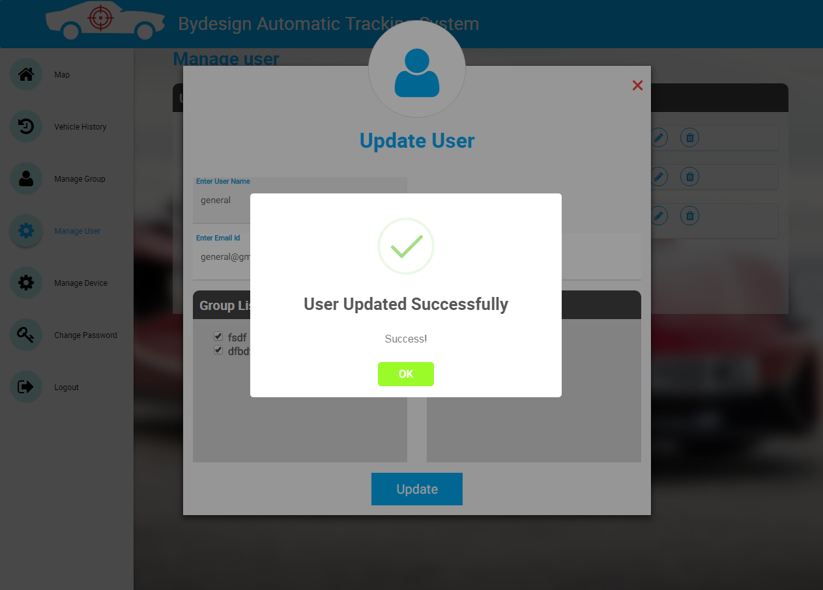

* On click of submit button, an alert is shown as “User Updated Successfully”.

**7.3 Delete User**

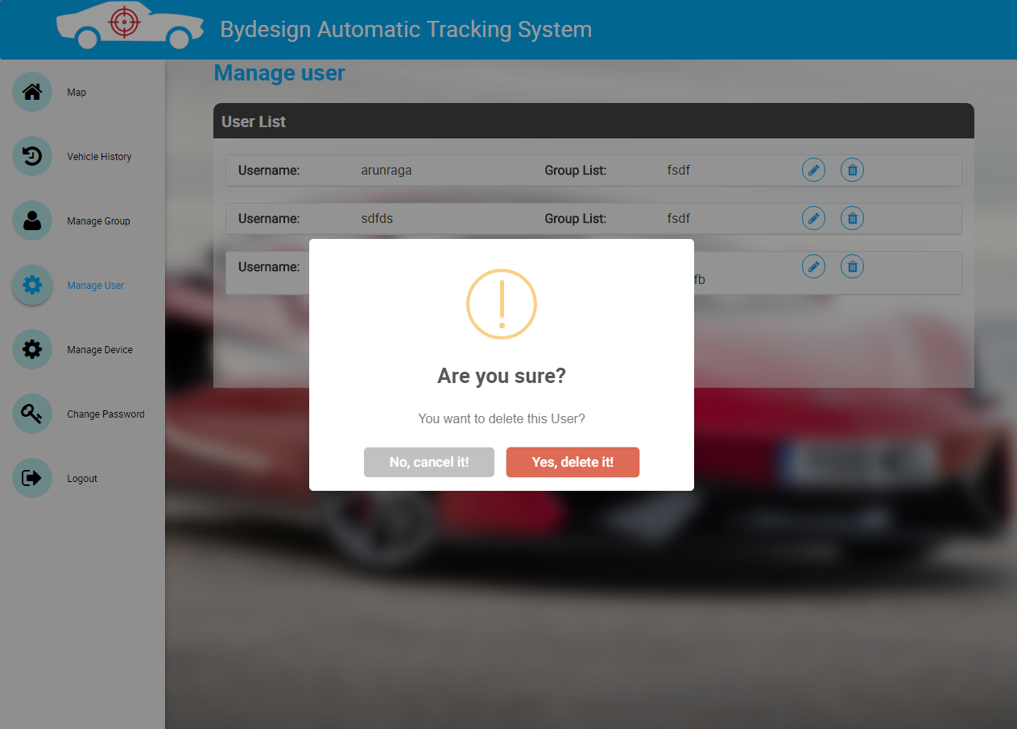

* By clicking on “Trash icon” on the list, you can see a confirm alert for deleting the user.

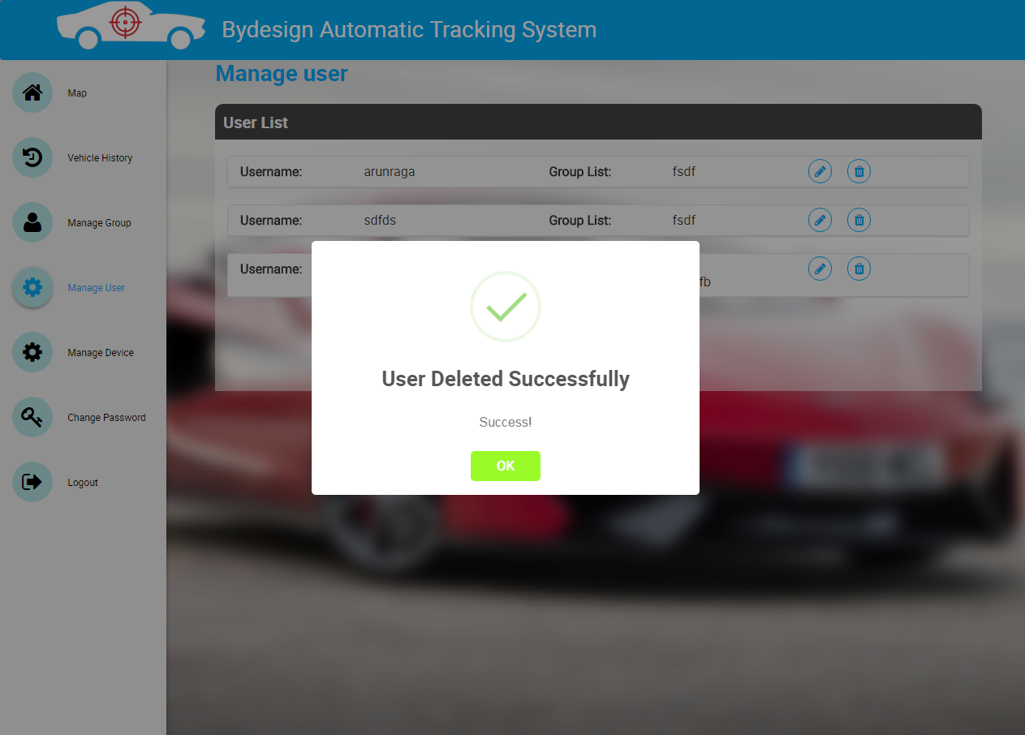

* On click of “Yes, Delete it”, an alert is shown as “User Deleted Successfully”.

**General User Overview Sketch**



**8. Monitor Group/Device (Map)**

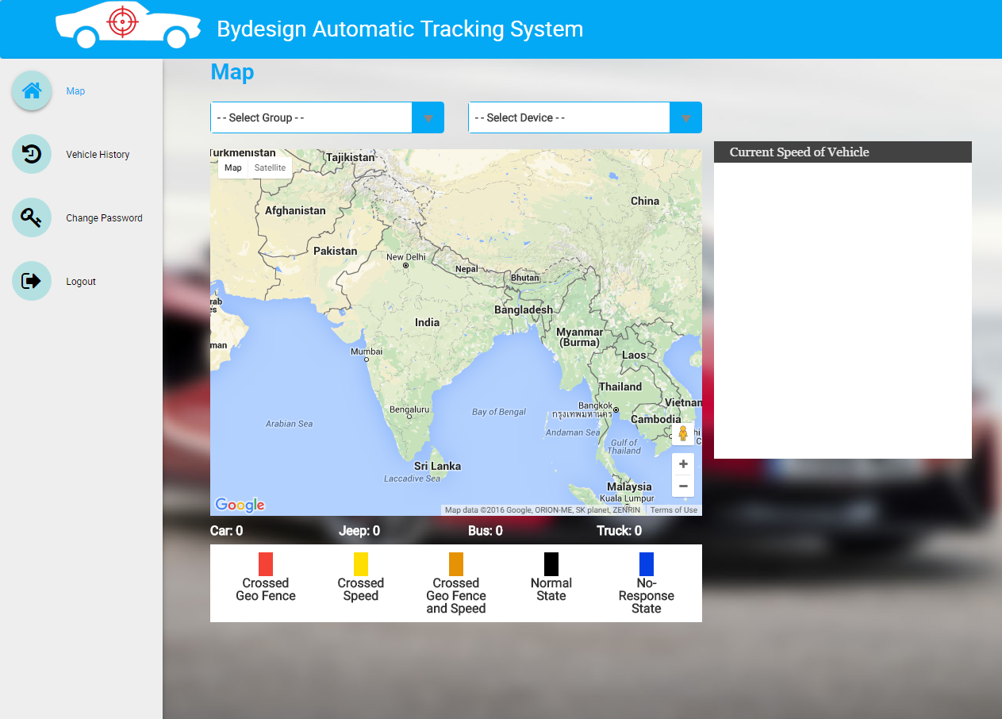

* After logging in as General user, the landing screen will be the above screen.
* It has selection based on,
  + Group
  + Device
* It also shows map with vehicle type & count.
* Legend with colors & description are shown below the map.
* On right of the map, an empty box is shown for tracking the current speed of the vehicle.

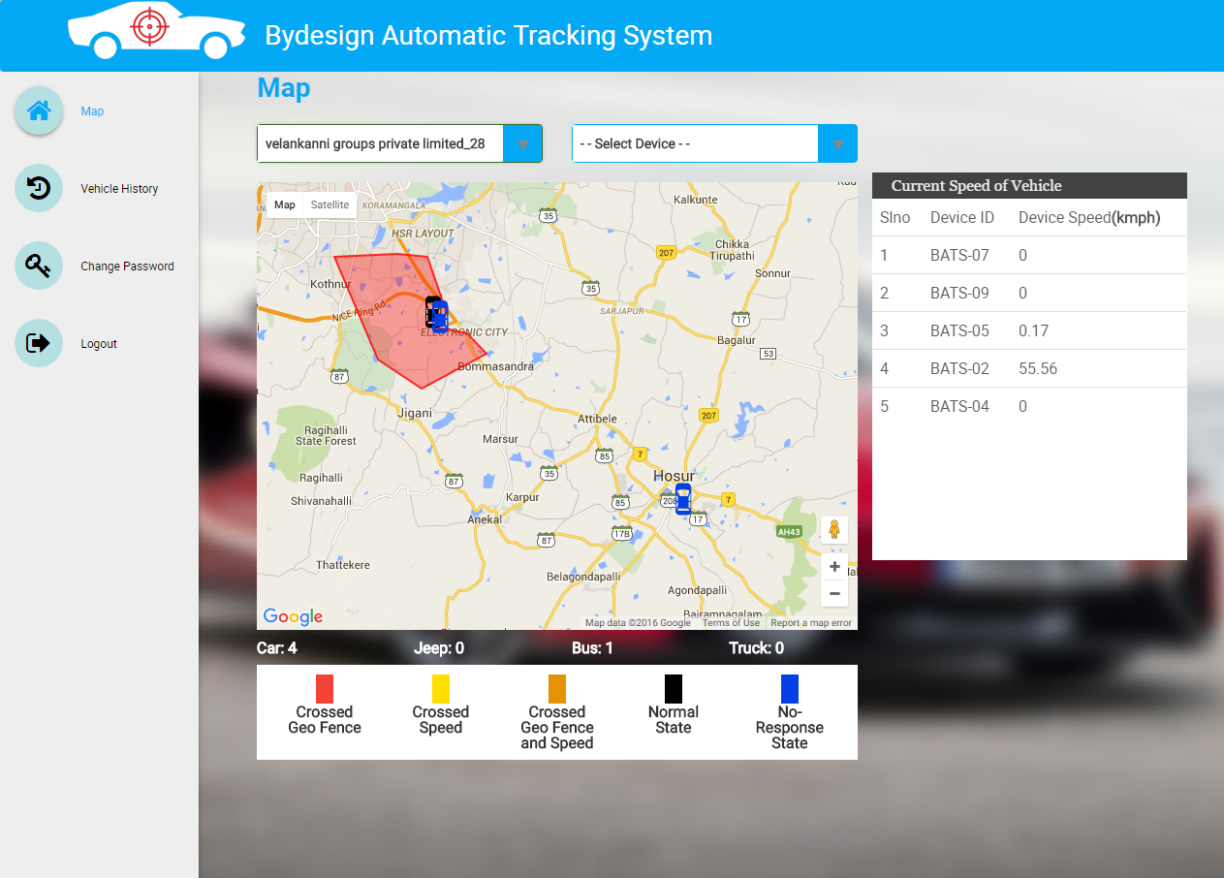

* Onselect of group from drop down, all the devices which belong to that group will be plotted on the map with geofence area drawn.
* The color of the icon on the map shows the status of the vehicle. The description for the color is shown at the bottom of the map.
* On bottom of the map, count of all the vehicles are shown.
* On right of the map, current speed of the vehicles are shown with,
  + Slno
  + Device Id
  + Device Speed

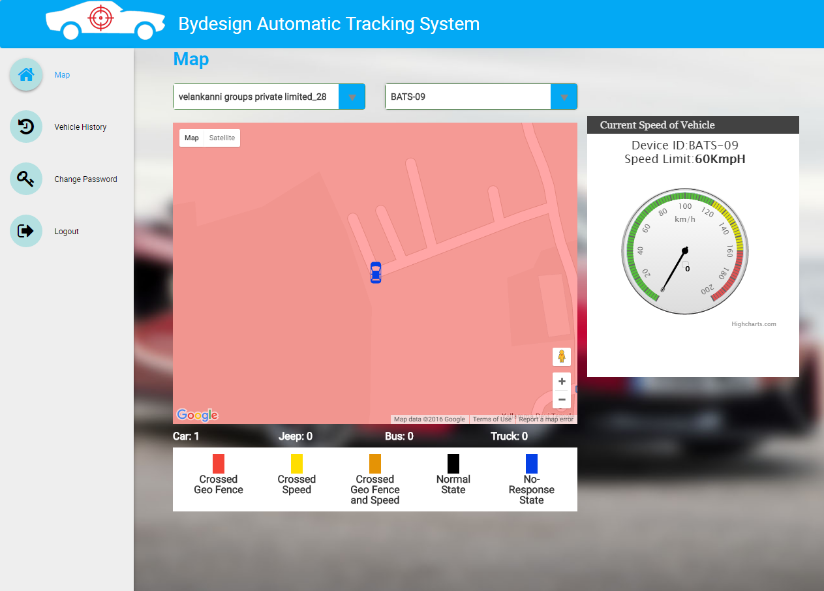

* Onselect of device from drop down, only the selected device will be plotted on the map with geofence area drawn.
* On right of the map, current speed of the vehicle is shown in speedometer.

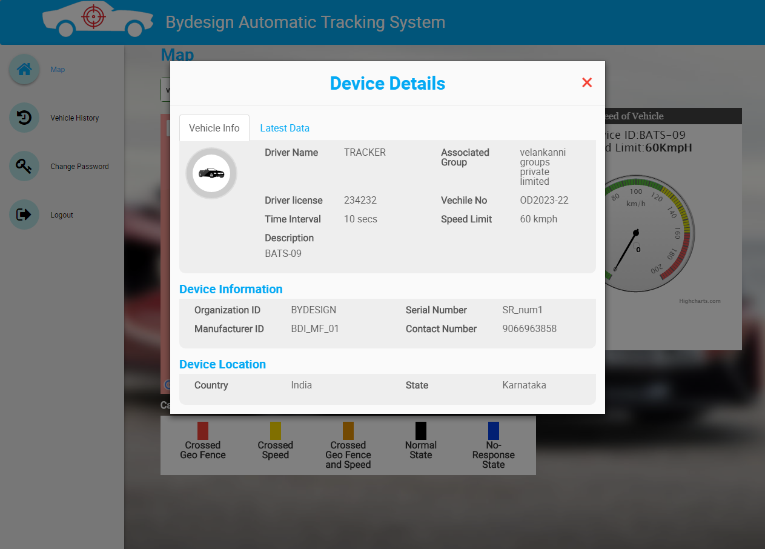

* Onclick of “Open me” button on the map, a modal is displayed with device details.
* By default, Vehicle info is selected.
* **Vehicle Info** Displays the following details,
  + Group Name
  + Driver Name
  + Driver License
  + Vehicle Number
  + Time Interval
  + Speed Limit
  + Description
  + Organization Id
  + Manufacturer Id
  + Serial Number
  + Contact Number
  + Country
  + State
* Also the car icon in the modal indicates the vehicle type.

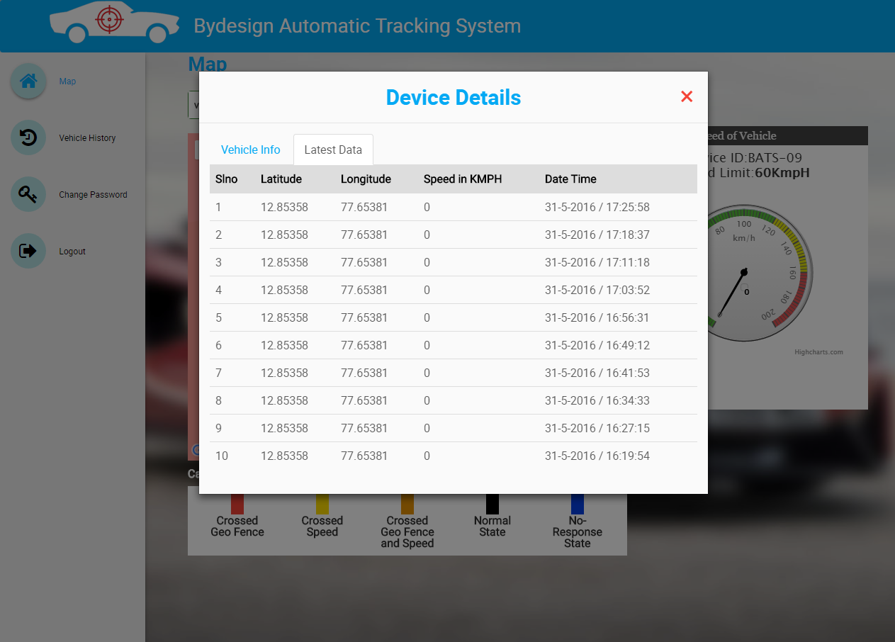

* Onclick of “Current Data” tab on the modal, it shows the last 10 data updated from the device. Such as,
  + Lat
  + Long
  + Speed
  + Date
  + Time

**9. Vehicle History**

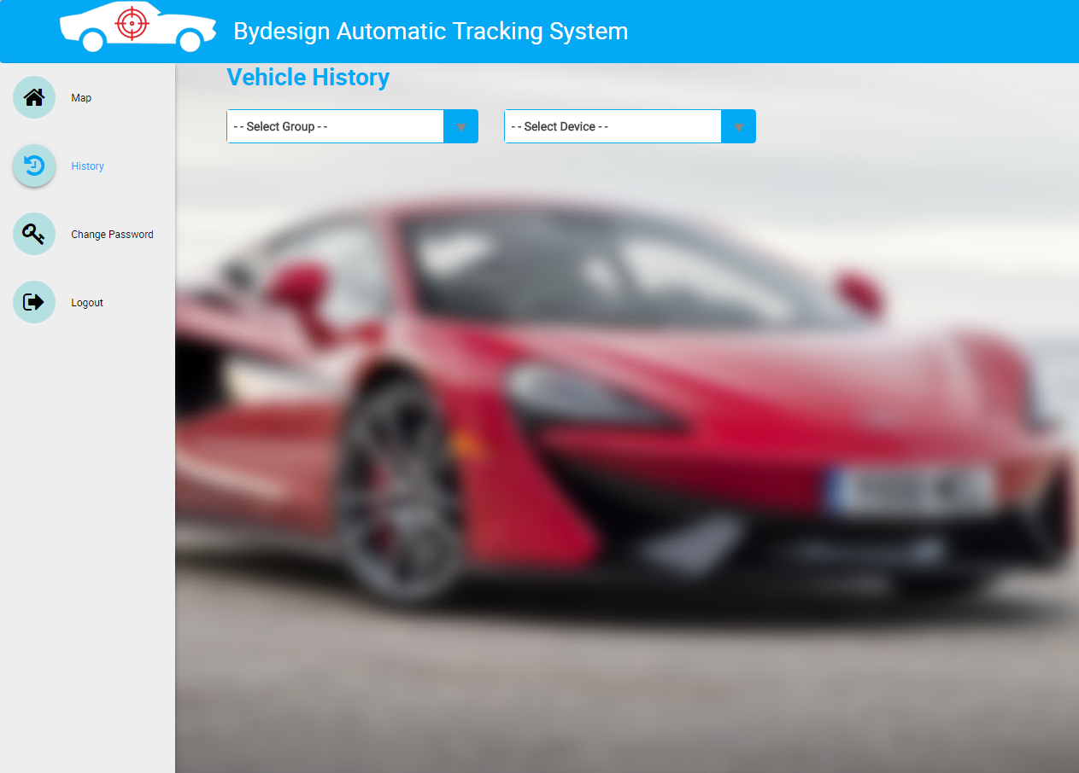

* Onclick of Vehicle History menu, two dropdown buttons are shown,
  + Group
  + Device

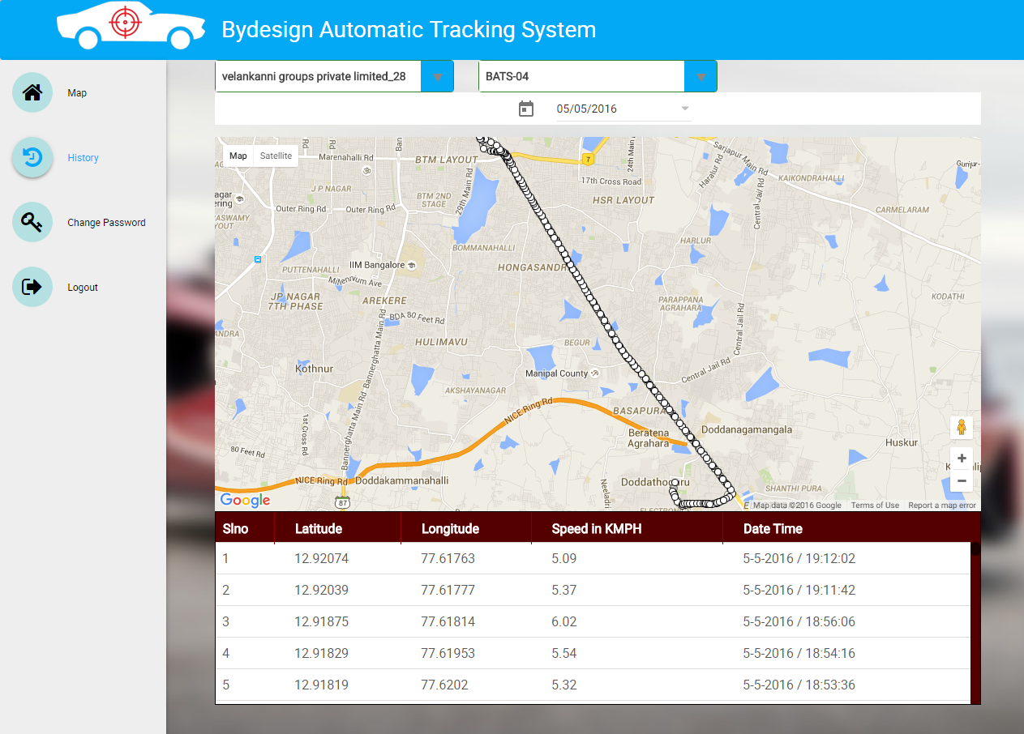

* Onselect of group, device & date, a map is shown with plotting the route where the vehicle has traveled.
* It also shows a table with following details of the device,
  + Lat
  + Long
  + Speed
  + Date
  + Time

**Common Features:**

**10. Login**

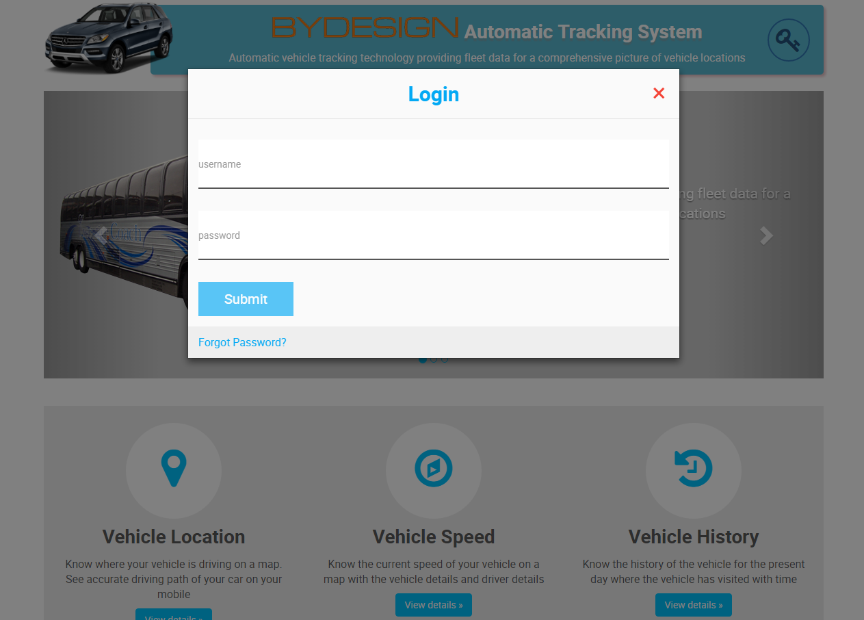

* Onclick of login icon on top right corner of home screen, a login modal appears.
* The login modal has two text boxes,
  + Username
  + Password
* It has Submit button & Forgot password link.

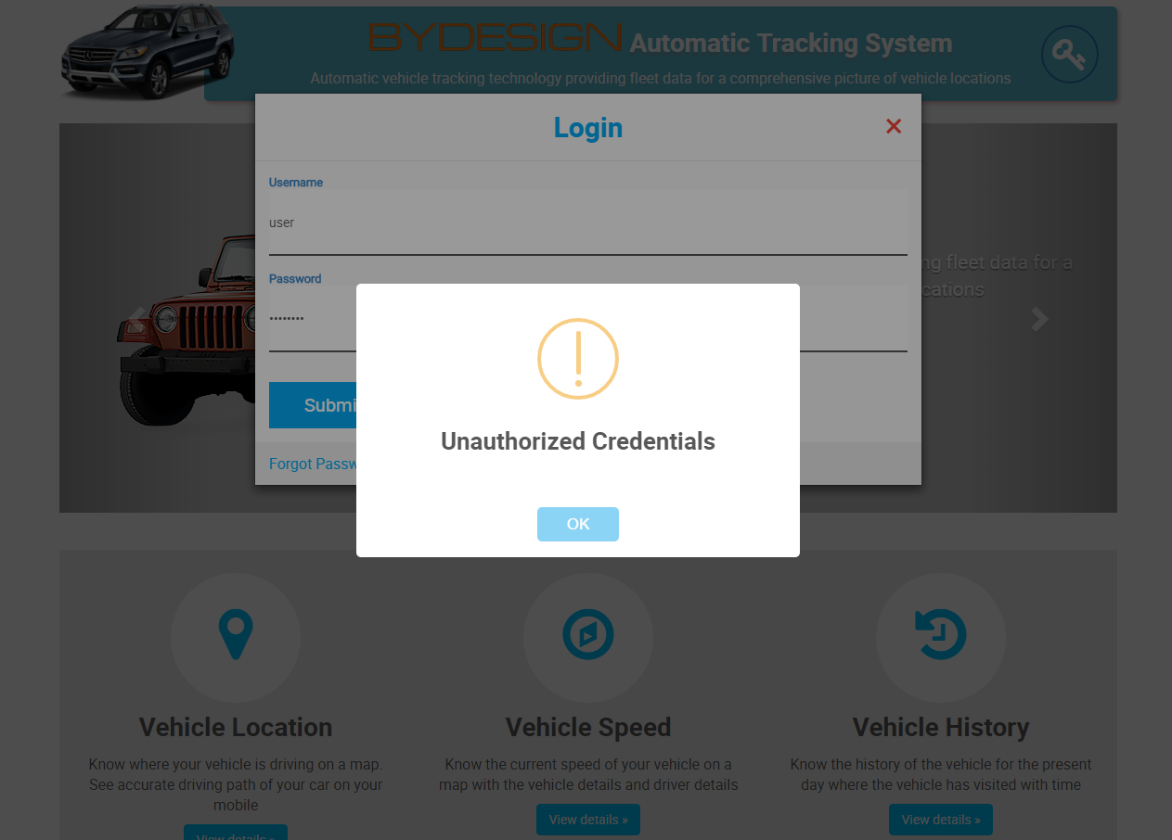

* If user tries to login by using the Unauthorized Credentials (credentials which has not registered with BATS application), it will throw an error alert.

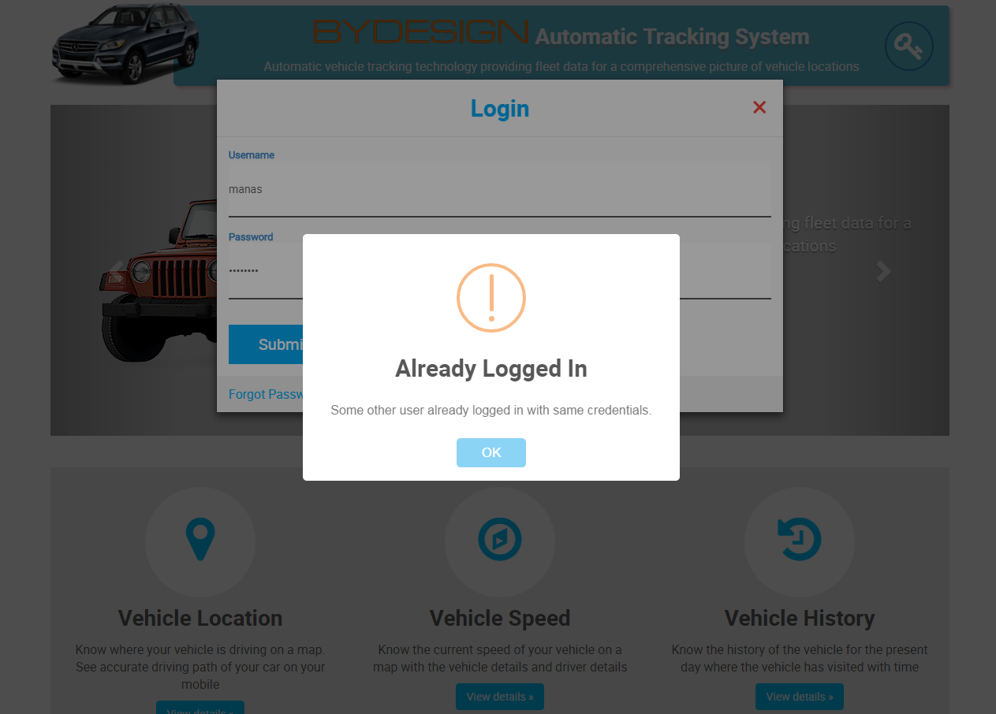

* If user tries to login by using the Credentials which has been already logged in by other user, it will throw an error alert.

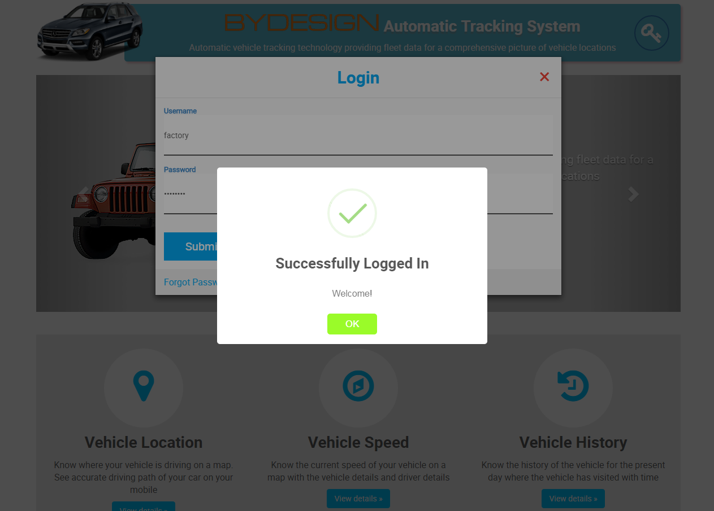

* On successful login an alert is shown as “Successfully Logged In”.

**10. Forgot Password**

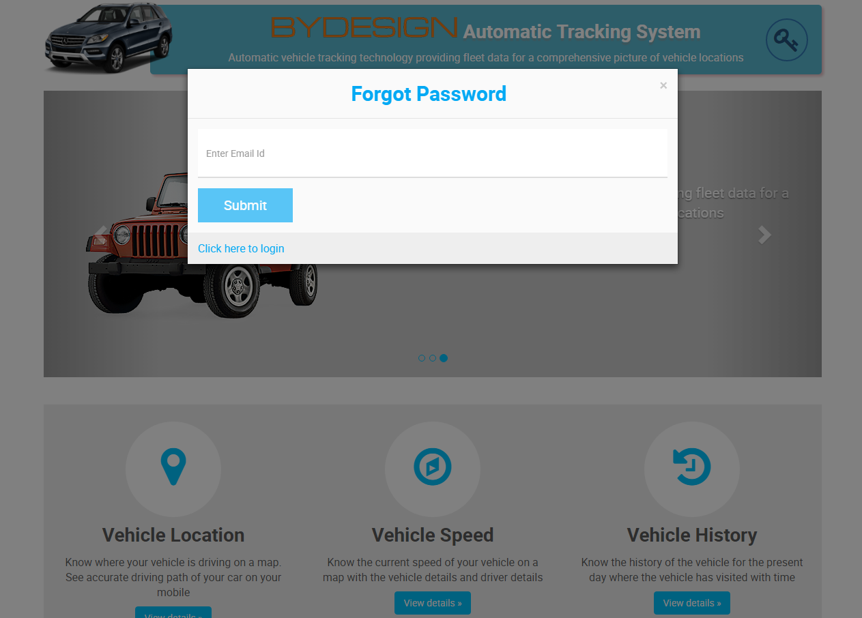

* On click of forgot password link from login modal, forgot password modal appears.
* The forgot password modal has email input field & submit button.

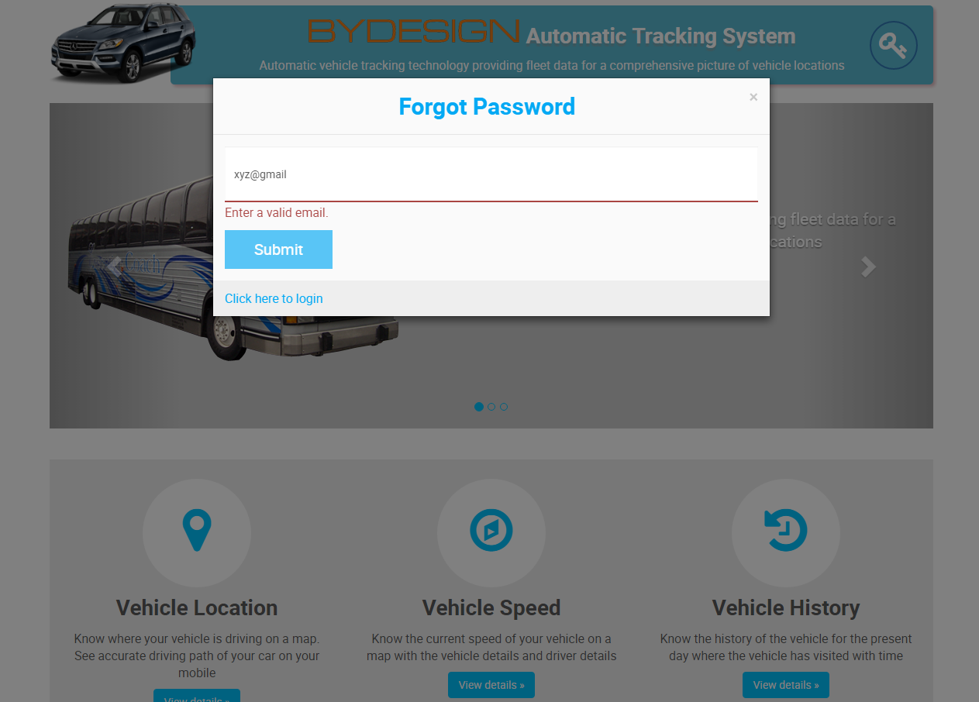

* If user enters invalid email id, an error message is shown.

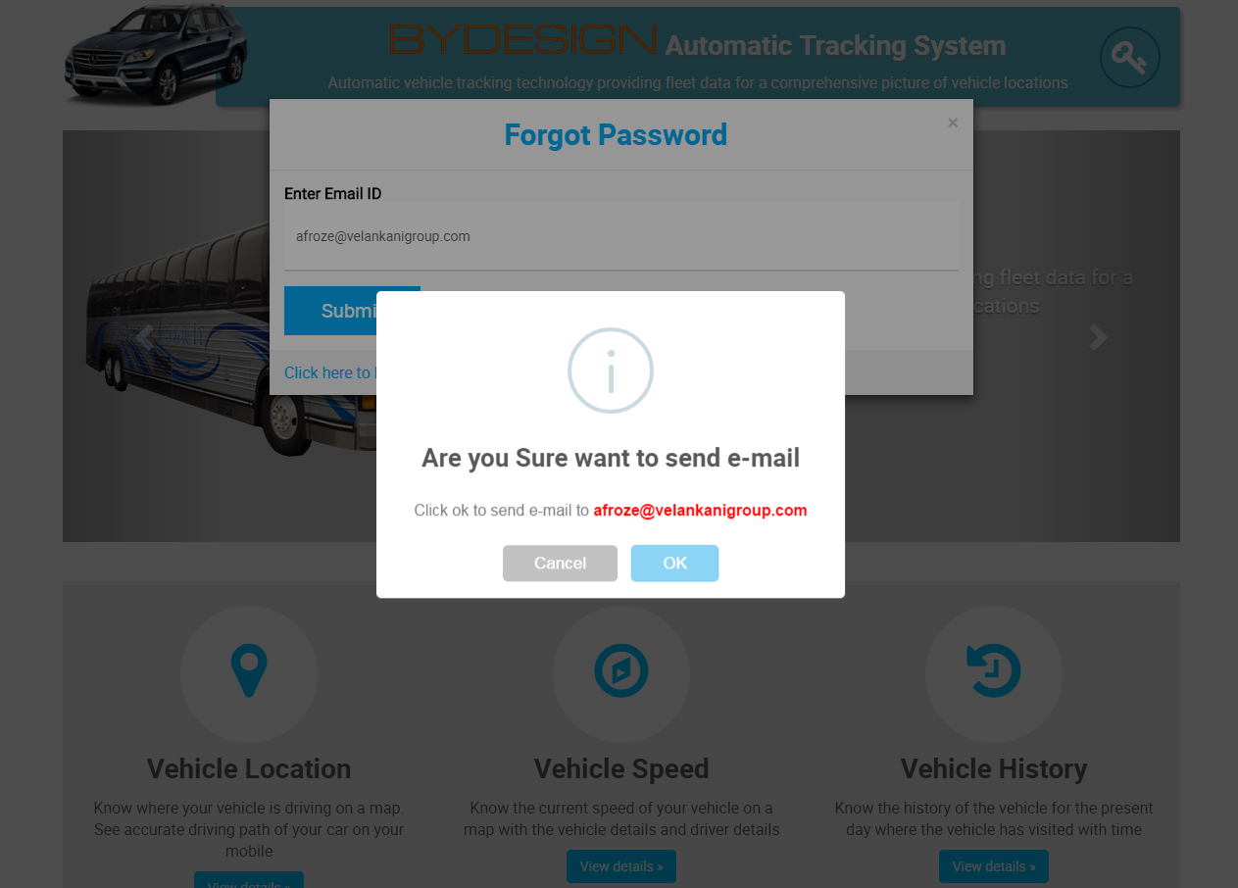

* On submit of email id, a confirm alert is shown.

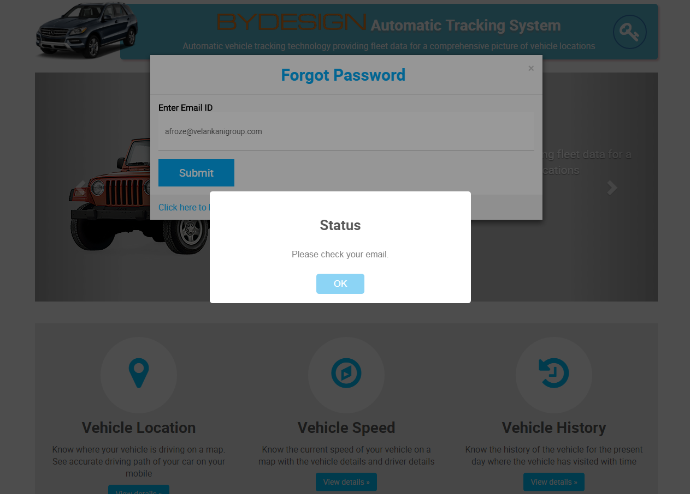

* On successful submission of email id, an alert is shown as “please check your mail”.

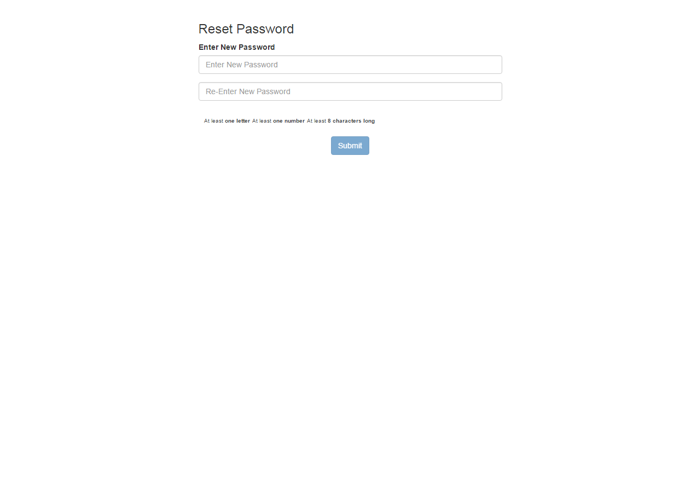

* In email user will get a link.
* On Clicking of that link will redirect to reset password page, which is shown above.

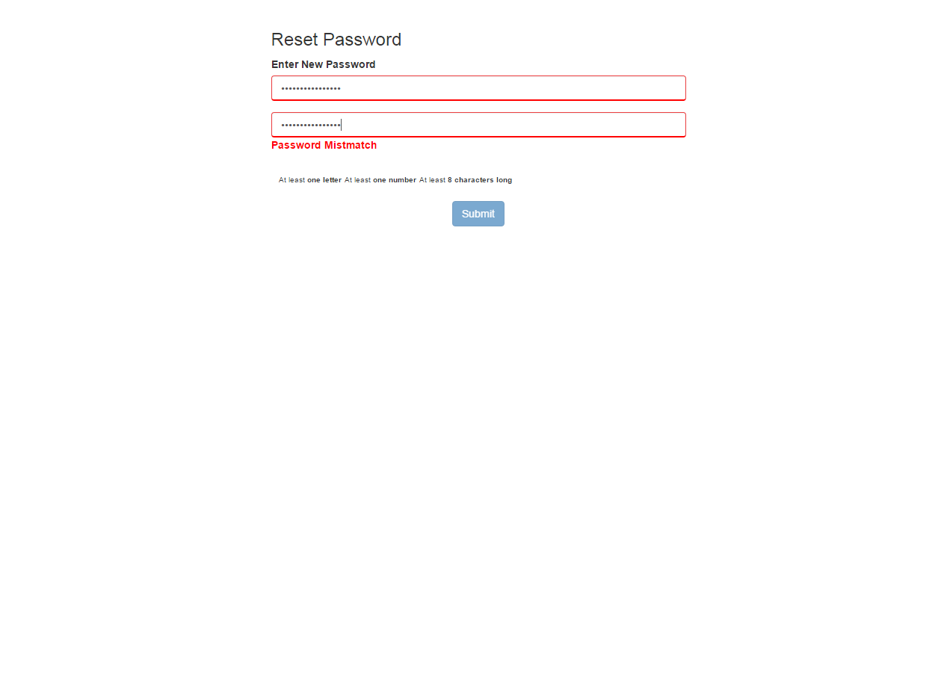

* If user is entering wrong passwords, a password mismatch error message is shown.
* On successful submission of the form, the password will be reseted.
* A password reset confirmation mail is also sent to the email.

**11. Change Password**

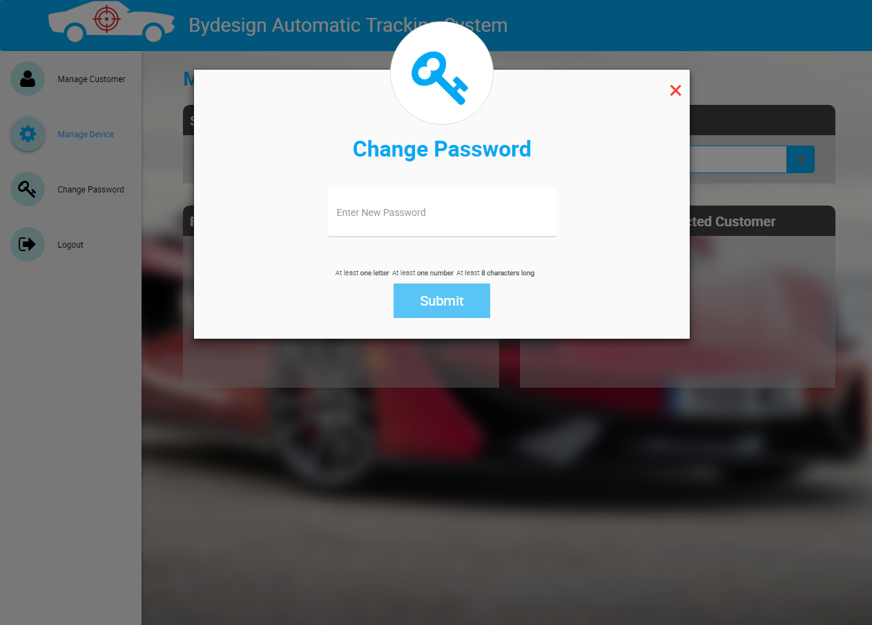

* Onclick of change password menu, a modal is opened.
* It shows enter new password field & submit button as disabled.
* A message is also shown above the submit button regarding the password.

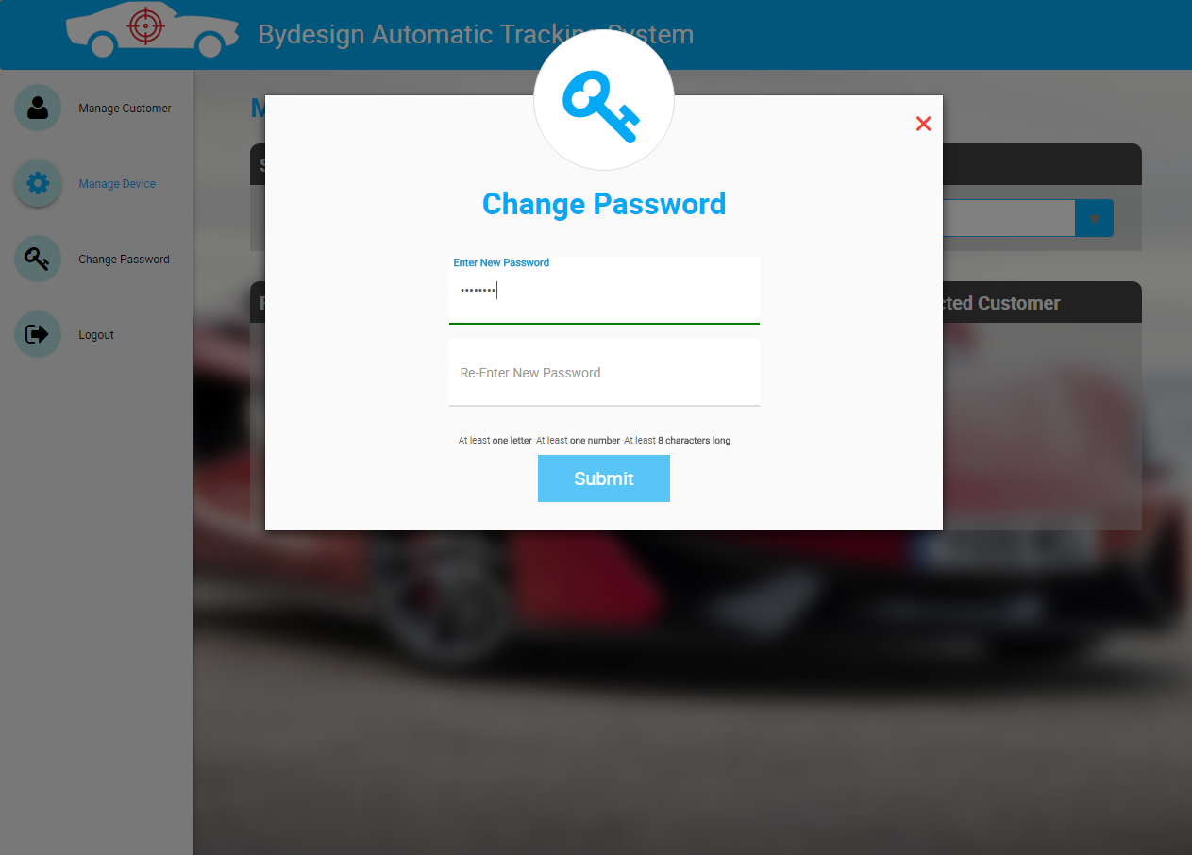

* On entering the valid password, re-enter new password input field is shown.

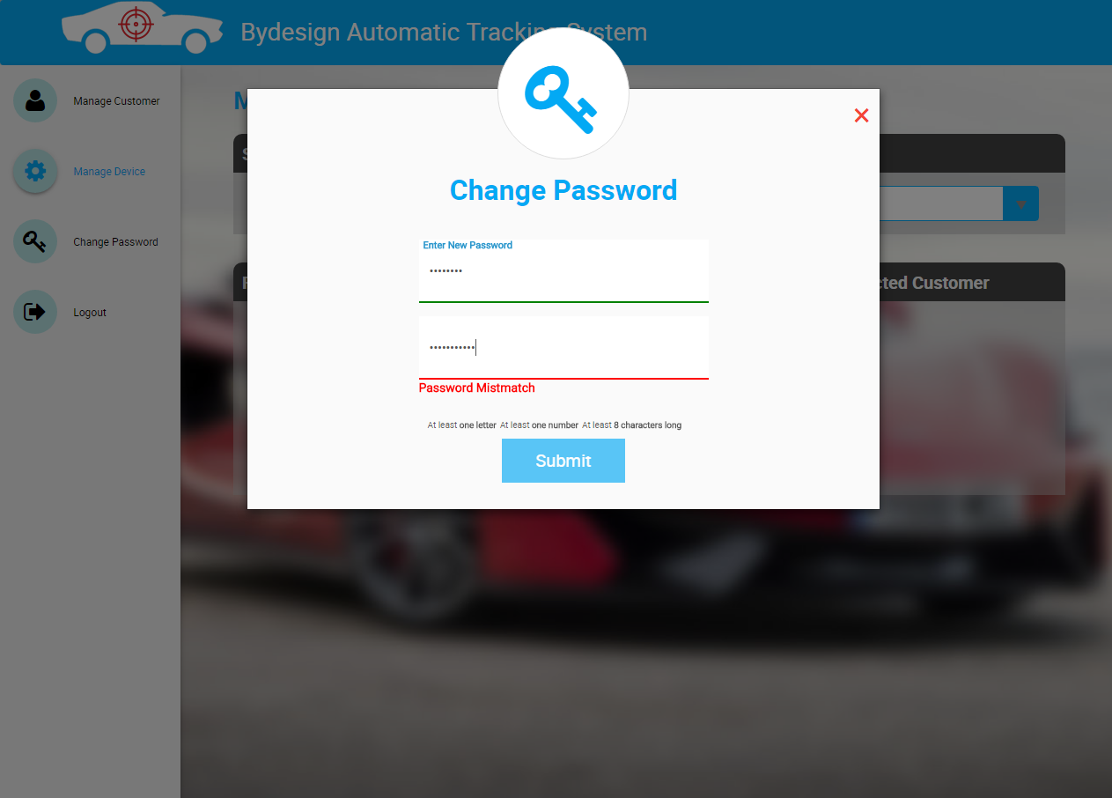

* If user is entering different password which does not match the previous password, it shows password mismatch error.

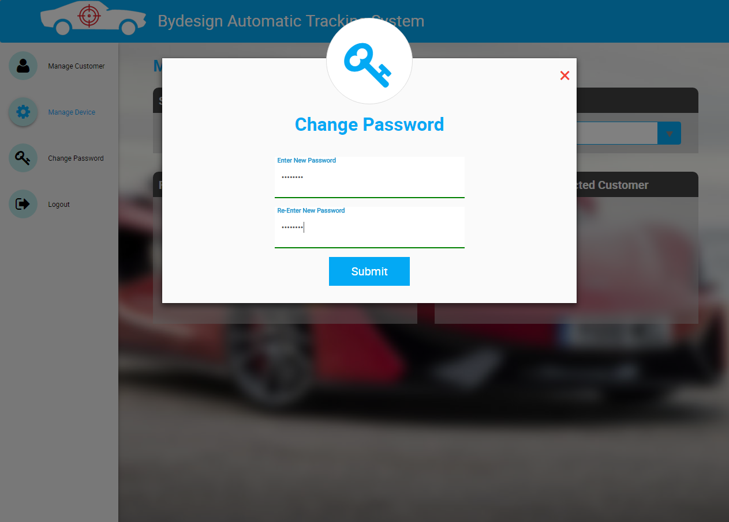

* If both the passwords are valid, then submit button is enabled.

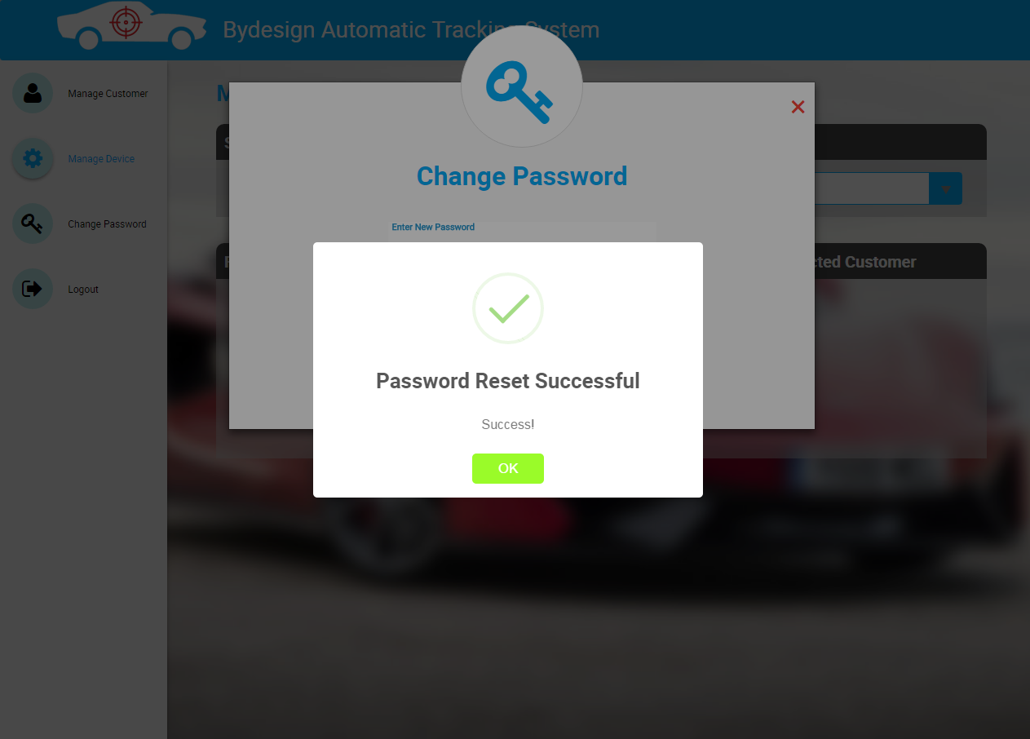

* On successful submission of change password form, an alert is shown as “Password Reset Successful”.

**12. Logout**

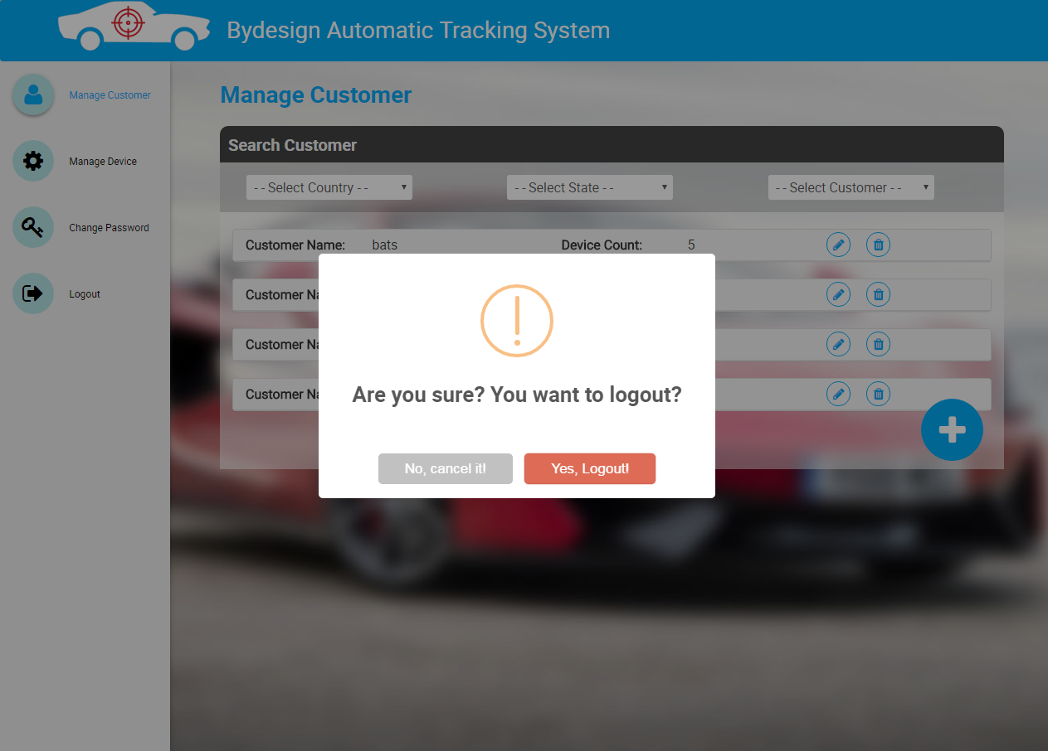

* Onclick of Logout from menu, a confirm alert is shown.
* If user clicks “Yes, Logout”, then user will be logged out from the application.